A MODEL FOR MAKING A SUSTAINABLE CHANGE
Çopyright Larry Moen 2015

1) Identify the goal behavior you want
- What exactly is the goal?
You want to be very specific here and cut to the essence of this, because each definition presents different options
EXAMPLE: Do you want to change your diet OR to reduce your weight OR to reduce your fat OR to be in better physical shape OR something else?
- Find a way to express the goal
  - As a positive
  - As something done now
  - As something active
  - As a statement to the unconscious for it to take control
EXAMPLE: “I shed pounds daily for no apparent reason.”
“ I consciously and unconsciously make choices daily that support my new normal weight of 160 pounds.”
“When I feel anxious I listen to calming music rather than eating.”
It may help to express the goal in a way that triggers another strong associational pattern:
“I am proud of my Nordic heritage, and Nordic women like me make daily choices to be physically active and have low body fat.”
“As an Alaskan I am a person who is adventurous and wily. I can handle things those in the Lower 48 can’t. I can rely on my Alaskan characteristics to get the energy I need when I need it – that is a far better choice than storing up energy in body fat.”
- Determine exactly how the goal will play out, step by step
Run through possible scenarios in which you will use the new goal. What would you do – exactly/specifically? What would you say to others? To yourself? Try to make it as specific and concrete as you can. Think the whole process through – vagueness is your enemy in this. If you can, walk it through so that your body movements and postures become part of the process. Don’t worry that in the real situation it may not play out exactly as you practice it or anticipate it – think of a sports team practicing for a game, or a symphony rehearsing for a concert. This is that kind of practice: it gets you ready, even if its not exactly what you will encounter later.

2) OBSERVE: Identify the specific characteristics of the problem behavior
After we know where we specifically want to go, we next need to become very specific about what we’re doing now instead, so that we can tease out the habitual patterns involved and the GOOD THINGS these “bad patterns” may actually be achieving.

- Start by getting good observational data
  - For at least one week identify in a journal or diary the following:
    - What exactly happens – step by step? BE VERY SPECIFIC.
EXAMPLE: I sit down to watch TV. I feel a need to snack. I get up and go into the kitchen. I think “I’ll just have something healthy.” I get an apple and return to the TV. I eat the apple. When done eating it, I feel a need to snack. I get up to go get another snack. I think “Maybe if I just have a few chips, that will take care of my need to snack. Maybe I need something salty.” I take some chips back to the couch and eat them. I feel the need to snack. I think “Maybe it wasn’t salt I needed but something sweet.” I go get some candy and return to the couch. I eat the candy. I feel the need to snack. I think “Maybe I just need a little more sugar or salt.” I get some more chips and some more candy. I return to the couch and eat all this. I feel the need to snack. I think “This isn’t working – AGAIN. I’ve already had more than I should. I don’t know what to do to stop this. I might as well have a bowl of ice cream – maybe that will fill me up and satiate me.” I get the ice cream and eat it. I feel the need to snack, but now it is time to go to bed. I turn off the TV and get ready for bed.”
    - When does it happen? When does it start and when does it end?
    - Where?
    - Who is involved?
    - What are the Plausible Rational Explanations (PREs) you have for why this happens? (e.g. “I have no self-control,” or “Maybe my metabolism is off due to my medications,” etc.)
    - What are the Plausible Emotional/Associational Reasons (PEARs) you have for why this happens? (e.g. “As a kid my family always had snacks when we watched TV in the evening,” or “As a kid it was always a treat to go to the movies and eat popcorn or candy while watching the film,” etc.)
    - What are your feelings at the time this behavior starts? (Sad? Irritated? Lonely? Happy? Numbed out? Etc. etc.)
    - What is your physical state (tired, agitated, hungry. etc.) at the time the behavior starts and ends?
    - What self-statements accompany the behavior (“I really shouldn’t do this,” “I’ve already blown it so why not do more,” “I deserve this,” “I’ll just have one and then stop,” etc.?
    - Ask questions related to highly possible causative factors specific to the behavior:
      - EATING:
        - What is the level of my anxiety? Uncertainty? Sense of deprivation?
        - What is my level of energy? Tiredness? Thirst? Boredom?
      - ANGER:
        - What was my expectation? Is this about fairness? About harmonizing?
      - ETC.

- Assess data for possible underlying reasons – anything that comes to mind (don’t worry about plausibility here - don’t assess these, just list the ones you think of)
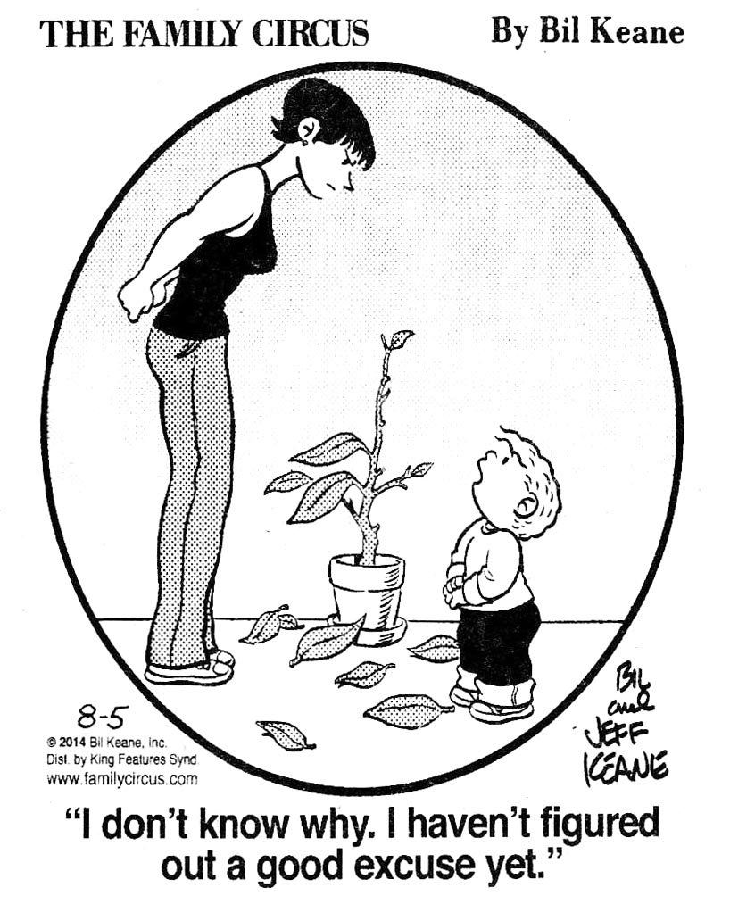
  - Logical/rational reasons, e.g. hunger, partner’s chronic lateness, etc.
  - Associational reasons, e.g. childhood patterns, cultural associations, etc.
  - Habitual reactions, e.g. identical actions/self-statements without nuances, etc.
  - DO NOT try to ID all possible reasons at this point.
  - DO NOT confuse PREs (Plausible Rational Explanations) or PEARs (Plausible emotional/associational reasons) with Truths -- treat possible reasons as theories or good guesses instead
- Identify the desired new behavior
  - Make sure that it works both rationally and associationally
  - Determine if this is to remain a conscious choice each time or is to become a “new normal” or habit, i.e. will be done unconsciously
    - If intended as a habit, structure it to be so uniform that it prompt the conclusion that “I don’t have to think about this, I always do XXX.”
    - If intended as a habit make sure that it has a point of closure
    - If intended as a habit OR for associational factors, consider images, symbols, rituals, visualizations and/or icons as aids in this process: speak in the language of the unconscious, not just the conscious/rational (if such an association is not already in your brain, or there is nothing that has “clean” associations, create a new one and reinforce it by repetition.
- Address logical/rational issues
  - This is usually fairly straightforward: get more sleep, drink fluids instead of eating, re-negotiate what seems fair to both parties, etc.
- Address associational issues
  - This includes feelings (although feelings are also generated by habits).
  - Explore associations to see if these can be altered or separated through more specifically defining the target behavior
  - Determine if new associational paths can be created, and if so then create these: e.g. specify as to time, place, circumstance, etc.
  - Determine if humor can be employed to alter associational patterns (see more below under habituational issues)
- Address habituation issues
  - Chart out the habitual pattern, playing close attention to each separate step in the process
    - Identify the specific sequence of actions and thoughts/feelings
    - Identify what parts are identical, e.g. snacking is continuous and unfulfilling regardless of what snack is chosen (whereas the individual snacks chosen each night might vary)
    - Follow the pattern through to its conclusion: when and how does the pattern achieve closure?
    - Remember that habits are always sequential, resistive to conscious attempts to change them once they have started running, and produce identical outcomes at various steps (and at the conclusion). If you are not identifying these aspects you may not have a habit OR you may be focusing too narrowly, i.e. in the example above the snacks themselves vary but the overall behavior is identical each time.
  - Utilize strategies for altering habits (see below)
It is important to write much of the above down. Externalizing it helps to clarify it. Getting it “out of your head” helps prevent ruminating on this. Writing it down also helps in the process of making it specific, not vague.
Once the old behavior and new behavior have been analyzed and clearly defined, its time to start making the desired change. Starting without this kind of assessment often leads to unexpected obstacles and/or erratic results. That said, you can also over-analyze and spend too much time trying to think things out – using that as a means to avoid the change. You don’t have to know exactly what’s going on with the old behavior, nor exactly how the new behavior will play out – almost always there will be some surprises. As General/President Eisenhower said, “In preparing for battle I have always found that plans are useless, but planning is indispensable.”
3) Use effective strategies for altering unconscious patterns
When an unconscious pattern has been triggered it resists conscious thinking to alter it. After all, the reason it became unconscious was that we didn’t have to think about it – so thinking about it is a waste of time, a mistake. When the unconscious is in control the conscious isn’t. Therefore if we want to change an unconscious pattern that has already been triggered, we need to use something else from the unconscious, not the conscious mind.
A common way this manifests is that a person decides consciously not to do something, then the unconscious pattern gets triggered and they do it even while consciously knowing they “shouldn’t,” and when the pattern is completed they regain conscious control and feel frustrated, ashamed, or simply befuddled at their inability to have stopped from doing what they knew and had decided they did not want to do.
The following are ways/strategies to prevent that from happening.
- DISRUPTION
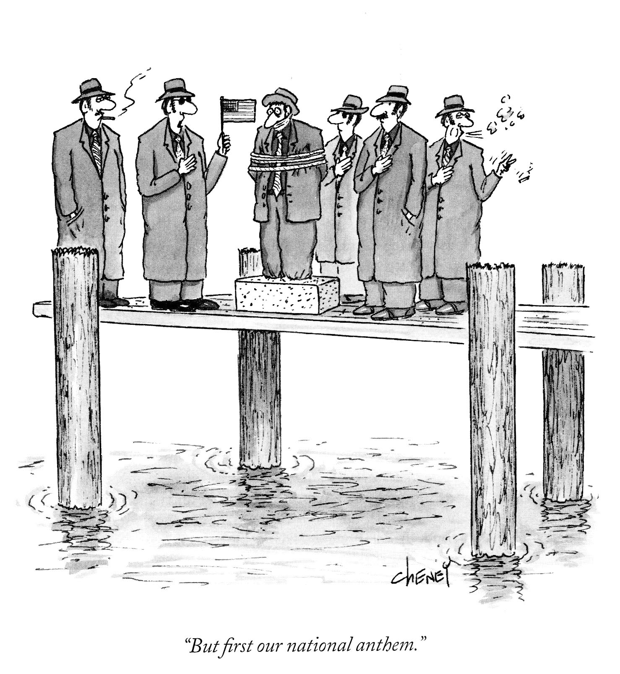

Disruption works by creating a new pattern which cannot be run in the mind simultaneously with the pattern you want to stop. It can be a pattern that is too similar to the existing one (e.g. trying to say the Pledge of Allegiance and the words to the Star Spangled Banner simultaneously), a pattern that is more powerful or requires immediate speedy action (e.g. we stop snacking if the house seems on fire), or a pattern that is contradictory (e.g. a pattern that brings up feelings of calm and being in control used to disrupt the existing pattern of anxiety)
  - Analyze the undesired current pattern for disruptive potential, i.e. for preventing the pattern from continuing without having to have conscious choice
    - Look for the EARLIEST EASIEST link in the sequence to break: breaking ANY link causes the chain to fail, you need not focus on breaking the strongest ones
    - Use a symbolic or sensory-based cue to begin a disruptive new pattern
    - Disruption requires that your conscious thinking have an alternate choice available immediately – you must have anticipated the situation. If you don’t have an alternate choice fast enough your unconscious will take back control of your actions and choose one or the other or give you an often bizarre hybrid (e.g. “the flag of the United States” and “the Frog of the United States” come out spoken as “the frag of the United States.”
    - MONITOR DISRUPTION for the appearance/awareness of unexpected causes or associations.
The great danger in disruption is that an uncompleted pattern creates what I call completion anxiety. Reality doesn’t feel right if what we “know must happen” doesn’t. When something starts we need an ending. If you disrupt a pattern but don’t provide a sufficient sense of ending, of completion or closure, you may create extreme anxiety which will choose even obviously bad choices simply to get to a resolution. Typically at some point a person will do something to force things to come to a conclusion so that the pattern can end.
- ANTICIPATION and CO-OPTING
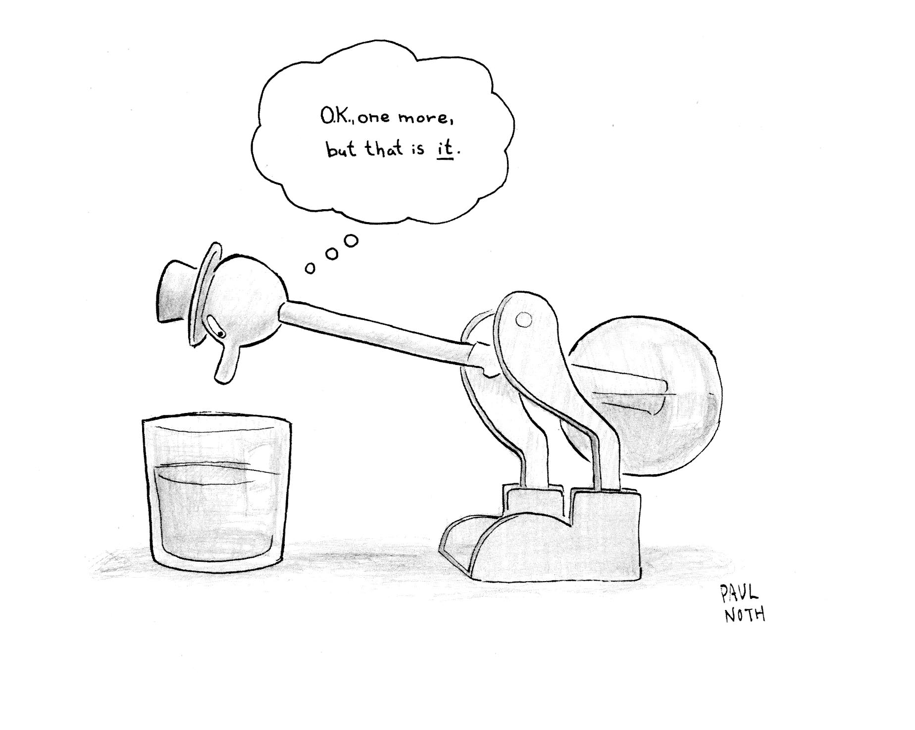
You can use anticipation to modify or offset the initial triggers for a pattern by using one or more of the following techniques
    - Remove or alter the triggers pre-emptively. For example, if a snacking trigger is hunger at 10 PM, adjust your dinner meal to 8:30 or 9 PM to reduce or eliminate this trigger. If over-spending is triggered by going into Nordstroms when outside, remove your credit cards before going into the store and instead carry $100 in cash. REMEMBER: ELIMINATING A CHOICE does not alter a pattern, it only defers it. It can also rebound on you, creating a binge. It is almost always better to acknowledge the choice but find ways to encourage not taking it, or to reduce the impact of taking it.
    - Begin another compelling pattern right before the undesired pattern is due or likely to be triggered. This is best done if this is a pattern that is incompatible with key elements, triggers, or links in the undesired pattern. If anxious eating starts at 8 PM, begin a 30-minute meditation routine at 7:45, or a sewing/knitting/other hand-engaging or food-resistive pattern then. If this pattern is sufficiently powerful it can block the old pattern from starting, and sometimes that will be effective enough that the old pattern will not start after this new pattern is completed. You may need to experiment to find the right blocking pattern or sequence

- SATURATION and TIMING
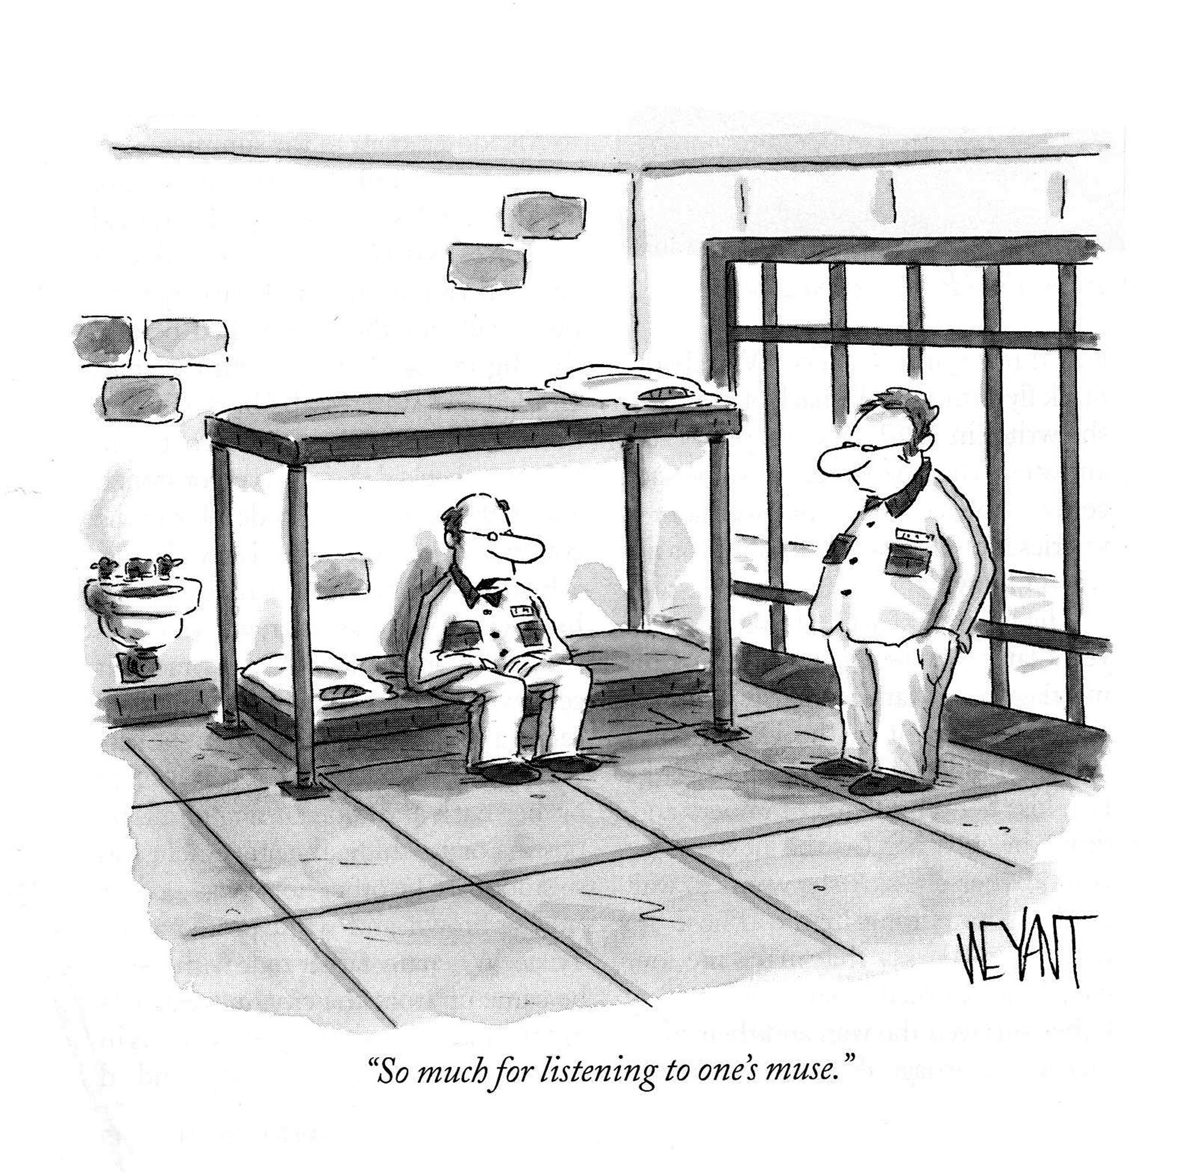
If you can determine what a primary cause for a pattern is, you may be able to alter a pattern by providing more of what is desired in another way.

Alternately, adjusting the timing of the patterned response to become slower can either mitigate the undesired elements or cause a pattern to fail (remember, the unconscious wants things to happen quickly)
    - As an example, if you determine that you have a craving for sweets, identify something that is intensely sweet – the epitome of what you desire. Instead of triggering the sense of depriving yourself by choosing half-measures (which typically leads to over-consuming these and still feeling unsatisfied), “give in” to the desired indulgence. Often doing so results automatically in a slowing down to savor the desired item or to deal with its richness: extend that sense of savoring. If the item is served hot, serve it extremely hot so that you have to slow down to eat it. Ditto if it is served cold. Utilize small obstacles – remember the example of the suicide bridge in Washington D.C.s Rock Creek Park. Freeze the candy!
    - Even if you are not using a saturated response you can still benefit by taking steps to slow the process down. Look for options that fit the pattern but are simply slower to access. Pay in $1 bills. Serve foods so cold that quick eating leads to “brain freeze.” Put the chips on a shelf so high you need to climb a stepladder to get to them. Slowing the process down stresses the pattern, and creates more natural opportunities for it to be disrupted. Little things can make a big difference. Frustrate the pattern – don’t eliminate the choice, but do make it harder to make.

- DIVERSION
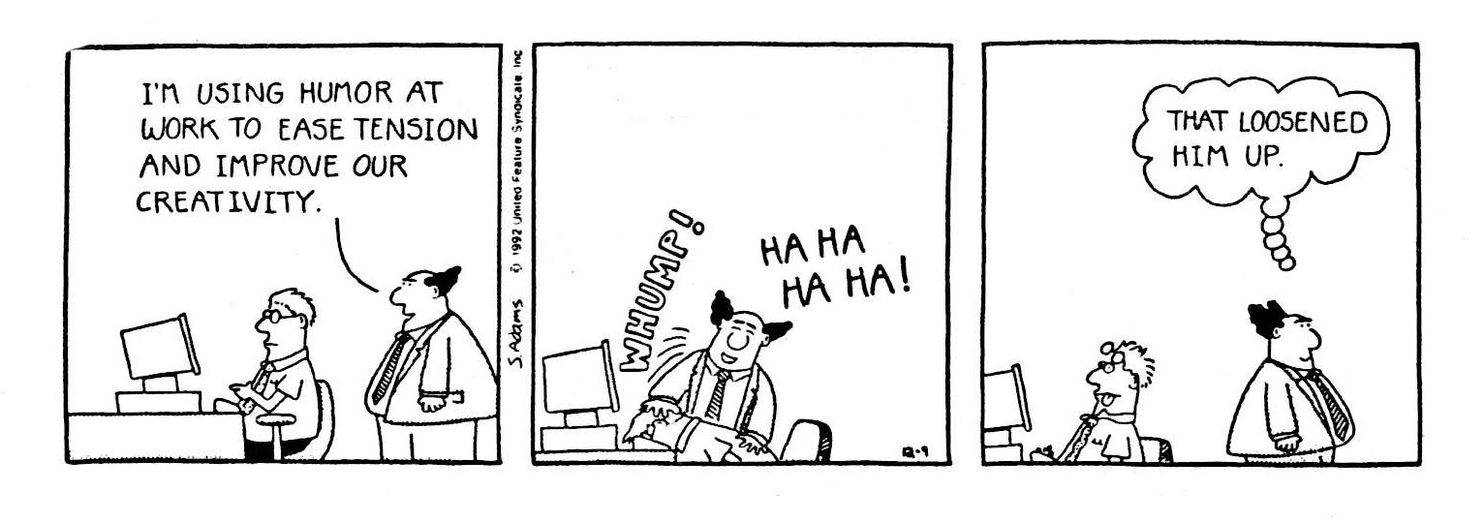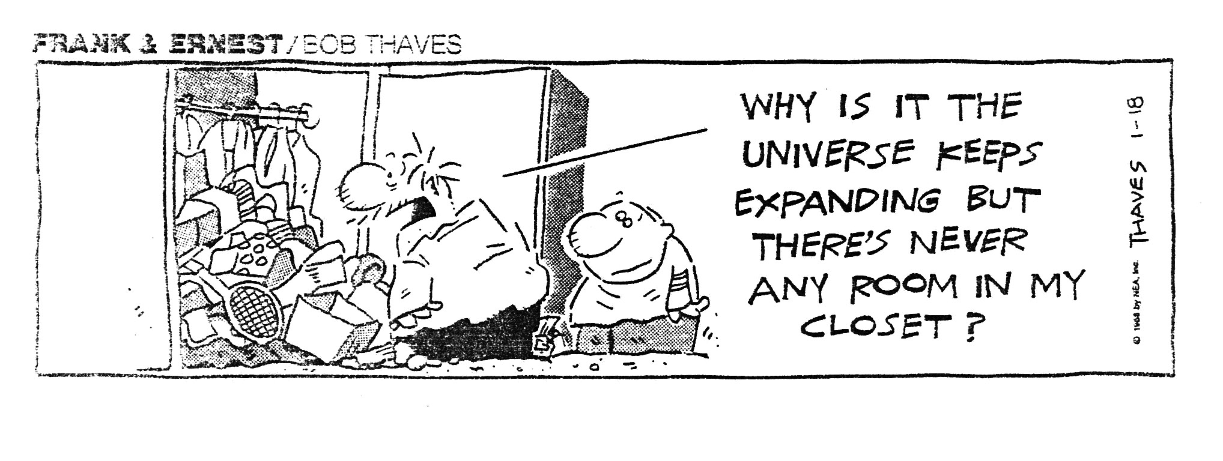
An effective technique is to find a point in the pattern where you can deflect or divert the old pattern onto a more beneficial new one. This is the principle behind much of humor and magic: we start a pattern expecting it to play out normally, but we are instead diverted and come out somewhere else. Our mind often finds enjoyment in that process – we like jokes and magic. Find a point in the old pattern where you can use a non-rational way to divert things: a word swap, a pun, a strong association – but different association – that switches the unconscious/associational thinking onto a new track. This can be a diversion that is strange and creates humor, or a diversion that takes us to an alternate and more desired ending.
    - Humor: When bored I seek out a snack – in the cabinet with the snacks I’ve put in front a model train on a track. I know I need to keep on track with shedding weight. (After all, I’m in training!) A train takes me where I want to go, and I want to go to the beach in my new swimsuit. It’s time to plan out some more details about that trip. Instead of snacking I end up planning out the trip. and I kind of enjoy my quirky little twist that got me there.
    - Desired ending: The example above leads to a desired ending, but you don’t need humor to get you there. 12-Step programs divert people from craving a drink to calling their sponsor. You also can, through association and repetition attach a new or existing pattern anyplace onto an older pattern – this is basic operant conditioning, along the line of Pavlov’s salivating dog. This takes awhile and MUST BE INVARIANT ENOUGH that it will become unconscious.

4) Make the new pattern unconscious
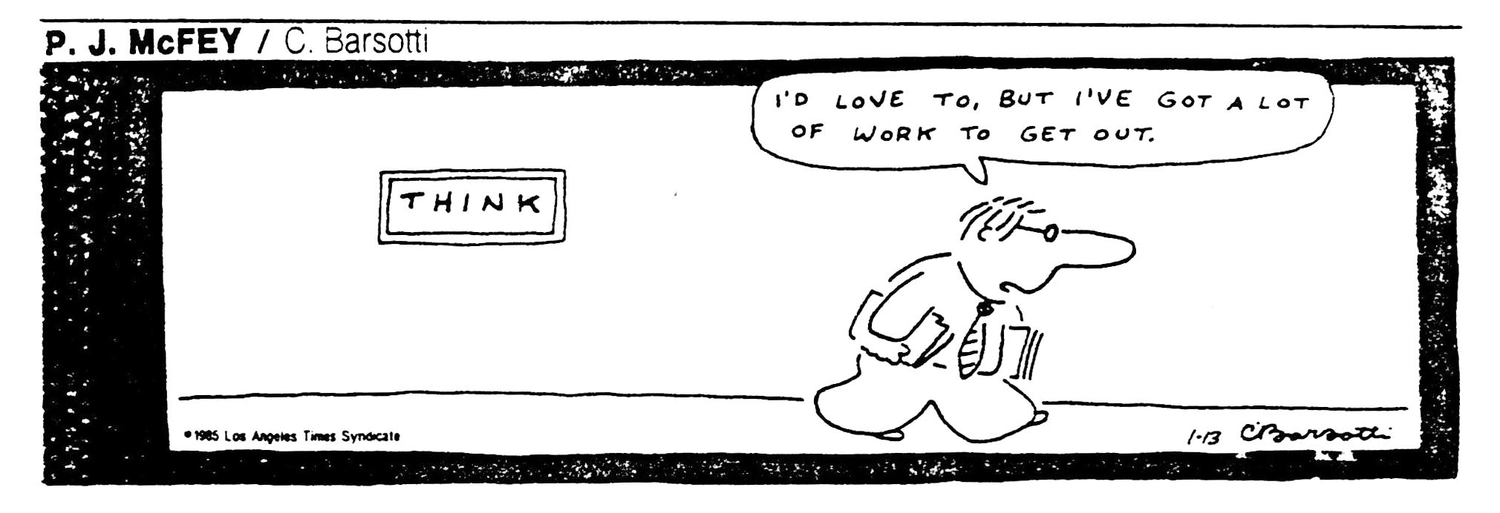We only have a limited amount of conscious attention available – consciousness is not good at multi-tasking. Whereas our unconscious handles thousands of things simultaneously, our conscious thinking starts to falter quickly, and for most people keeping track of 5 or more things at once is extremely difficult or impossible.
It is unlikely therefore that we’ll be able to devote one of those five things exclusively to the new change we want to make. And when we stop consciously paying attention to something, our unconscious takes over. Which means that we will most likely lapse back into the old unconscious patterns.
Therefore we want to get the new pattern into our unconscious as quickly as we can. To do that we need to get the new pattern to become something that is so regular, so always the choice taken, that we “don’t have to think about it.”
So initially we need to pay conscious attention and think about the new pattern a lot, but think about it in a way that has little or no variation in choice. The more we spend time thinking about different choices, the less likely this is to become a new unconscious pattern.
In practice, what this means is that what we initially want to do is repeat almost by rote whatever our “fallback” pattern will be – what if we are not paying conscious attention we will “automatically” do. Examples: making or choosing to eat a salad for dinner; eating a low-calorie prepared meal; carrying $40 in your purse or wallet for impulse purchases and never spending more than that; always doing a quick cleanup of the kitchen after a meal; always paying bills the same day they arrive; having a set of pre-stamped envelopes and thank you cards at home and always filling one out after being with friends; etc.
These are the fallbacks, not the only choices. If you can pay attention to the situation or issue, you will be able to make a variety of choices. This is what you want to have happen if you are not paying attention, if you need to let your unconscious patterns handle the decisions.
Repetition of an identical choice is what is needed. The more repetition and the longer the time spent repeating it, the faster and more likely you are to get to the point of “not having to think about it.”
Here are some helps in this process:
- Pair the new pattern to something you already routinely do.
In one research study in a group of persons who repeatedly reminded themselves at least 7 times during the day to eat healthily 28% were able to lose a pound a week. But in a the group who reminded themselves at least 7 times a day when they had anything to drink 58% lost a pound a week.
2) Use “unconscious language” to express the new goal
Repeating your statement of your goal as many times as possible during the day is one path to making it unconscious. However, the person who can do this 500-1000 times a day is rare. So use SYMBOLS and IMAGES instead – speak to the unconscious using the language of the unconscious. The unconscious also likes puns, so use them, too.

As examples:

Put a picture of a shed or shredder with the word POUND written on it somewhere where you will see it directly or peripherally multiple times a day (and especially near or around whatever triggers you to your pattern of eating)
OR
If you are using the “I’m Nordic” association, use a pen when writing that has a Viking/Nordic motif
OR
Take a picture of your scales registering your desired weight, and put copies of the picture in places where you will see them frequently
OR
Carry a small object in your pocket that symbolizes your new pattern of choices
OR
Use multiple such images, icons, or symbols.

3) Pair the new behavior (associate it) with a strong existing pattern that you routinely encounter
You can also create new associations to these behaviors which are even more global – what if this new statement was triggered every time you saw the color orange? What if you bought and wore a new ring that triggered it?
Be creative and experiment, and TRUST YOUR INTUITION on this – what FEELS RIGHT to use or attach?

To use the second method, the need for speed, you may want to induce a trauma. Please see my paper on that method.

4) Remember system dynamics
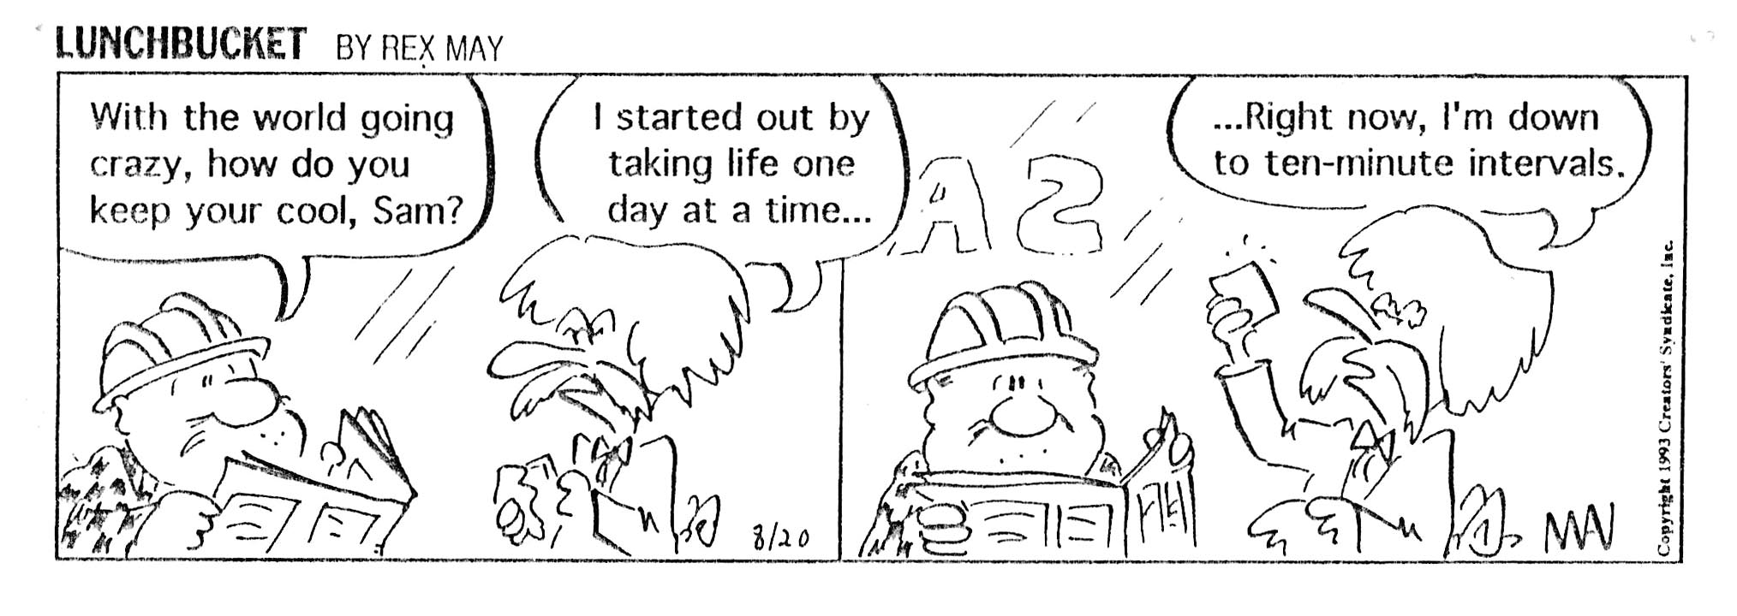
On patterns where we are re-setting what we regard as normal – as what we do without apparent mental effort – we need to remember the dynamics of systems of choices.
In such systems “normal” lies at the midpoint of our range of choices. Normal isn’t good or bad, it just is. Other people may see it as good or bad, but for me it’s just, well, NORMAL and effortless.
If I set up a range of choices where the worst acceptable choice is where I am now, and the best choice is at some other point I see as the best I can achieve, NORMAL WILL BE HALF-WAY BETWEEN THE TWO. If I weigh 200 pounds and see the least I can ever weigh as 150, then normal for this range will be 175 – the ½-way point.
Any weight loss between 200 and 175 will be on the “bad” side of normal – the loss won’t be good enough to be seen as/felt as good. Only the choices on the other side of normal (175 to 150) are on the “good” side.
This means that the first 25 pounds this person loses WON’T FEEL GOOD ENOUGH even though they really are good,
We can go into this in greater detail elsewhere, but the core thing to remember is that setting the range this way – seeing things this way – sets one up for discouragement and feelings of not being good enough.
The second aspect of system dynamics we want to look at is this: Because it takes time for our mind to accept a new normal, we need to ensure that we can sustain the effort needed for the change to occur for long enough for that to happen. The effort has to be consistent, otherwise we violate the goal we want of “not having to think about it.”
Often this means we need to approach a goal in stages. I may be able to sustain through a worst-case scenario only enough effort to get me to a new normal of 190 instead of 175. That’s great! Once I normalize at 190, the same amount of effort that got me from 200 to 190 can now get me down to 180. When I “plateau” at 180 I can then use the same amount of effort to get to 170.
Plateaus then become things to celebrate because they indicate that a new normal is being set. The new normal, like the old one, resists any real change.
Once fully set, however there are interesting benefits. Often at this point we can introduce older choices without them harming the process – if I gave up all ice cream to get from 200 to 190, I may be able to have some again – although it will be less, because 190 requires less.
The most important thing to realize is that this step forward-plateau-step forward process is actually what you want to see, and is taking you to your ultimate goal. 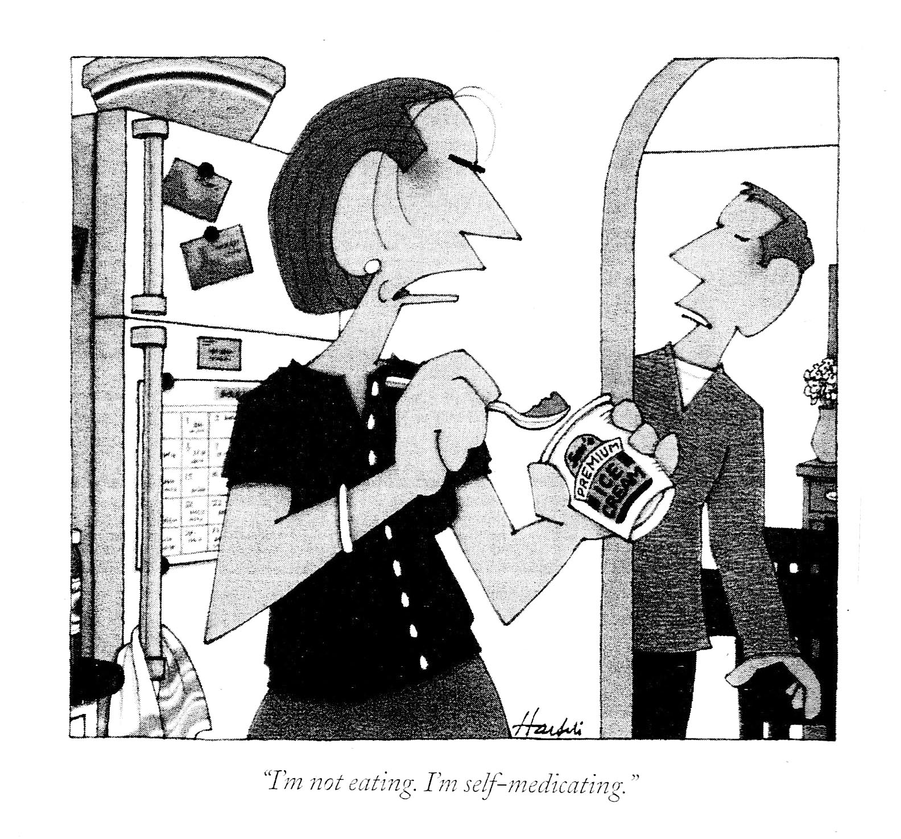

Conclusion
Although we could take this much further, perhaps this is a good point to stop. Sustainable change requires some clear understanding, and some of that is counter-intuitive. It certainly seems as if our rational decisions to do or not do something should simply make that happen. It seems as if once we see ourselves doing something we don’t want we should be able to rationally immediately stop it. It seems as if progress towards a goal should be steady rather than done in steps. It seems as if saying “Where I am now is the worst choice I’ll accept” shouldn’t make our initial gains feel inadequate.
My hope is that this paper can help you understand better why those things DON’T happen as we expect them to, why that makes sense and doesn’t mean we are “out of control” or our thinking is broken or defective or “against us.” Finally, I hope this provides helpful insights and suggestions as to what you can do to get the changes you want and to make them lasting.
I wish you all the best in that regard.