MORE or LESS
Downsizing: reducing the number of things in your life

Larry Moen M.Ed LPC www.utherapy.net (907)388-8963

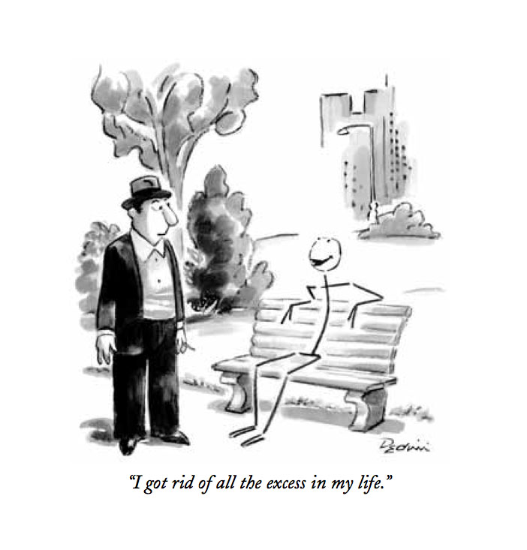
- The concept of white space
- Poetry vs. Prose
- Ownership – who or what owns the thing?
  - Curating vs owning
  - Do you own it or does it own you?
  - Moral and ethical aspects of ownership
  - Borrowed vs owned

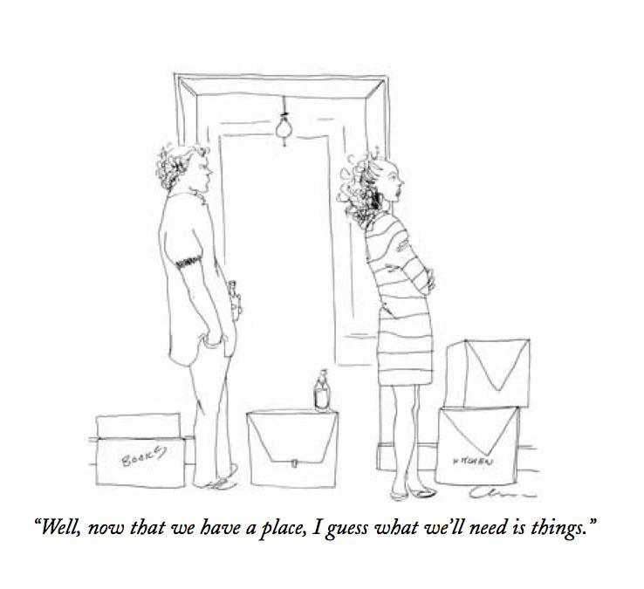
- Rational aspects of things (the thing as it physically is)
- Associational aspects of things (the story and meaning attached to the thing)
- Habitual aspects of things (the thing as part of a repeating pattern)

- Overcoming rational objections, and when not to
- Overcoming associational objections, and when not to
- Overcoming habitual objections, and when not to

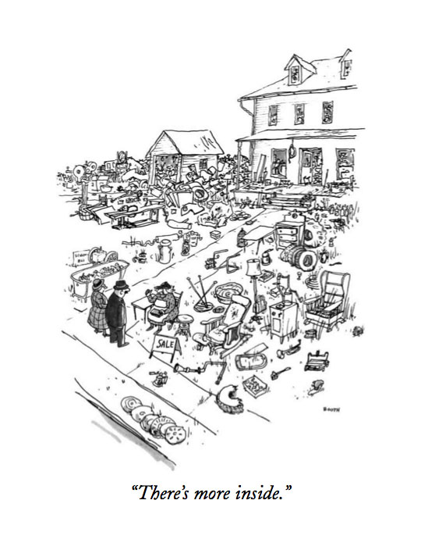
- Negative psychological consequences of having too many things
  - Increase in complexity and stress
  - prioritization issues
  - restrictions on freedom and innovation
  - ossification; inhibitions to growth and change
  - guilt and shame; self-blame and/or anger
  - confusion regarding self-image
  - feeling overwhelmed, out-of-control, or depressed
- Positive psychological consequences of having too many things
  - Increase in self-reliance and coping
  - Gains in self-esteem and perceived status
  - Increased choices and power/ability to influence and persuade
  - Cultural compliance and validation
  - Increase in pride
  - Increase in giving to and providing for others; philanthropy

- Time and space considerations for sorting and reducing the amount of things

- Practical approaches to reducing things
  - Do it with a partner
  - Do only as much at a time as fits the space and time you have available
  - Consolidate similar/identical things together when sorting and deciding, then keep them together as much as possible afterwards
  - Avoid any storage that prevents you from seeing what you have
  - Avoid stacking items: keep items individually available without having to move anything else to get to them
  - The nature of things is that things have a limited lifespan. If a thing has lived out its lifespan, be merciful and let it go, even if part of it is still viable. Hold things to the same standards as you would humans and pets – don’t prolong life for the wrong reasons.
  - Withholding the natural elimination process is called constipation, and is not a good thing. Our bodies get rid of what we don’t need or can’t use, even if it is good stuff. Too much is simply too much. It’s unhealthy to not let it go.
  - Accept the reality you live in, not one you don’t. We are not tremendously good at predicting future reality. We also usually will find what we need to cope with it when it happens.
  - If something doesn’t make you feel good to have it or keep it, do your best to get rid of it. This may mean replacing it with something you do feel good about having.
  - Avoid surrounding yourself with things that bring you down through their associations. Associations are powerful determiners of our actions and mood: don’t over-rationalize to keep something. If you find yourself rationally justifying why you should keep something, you probably shouldn’t. Consider other options.
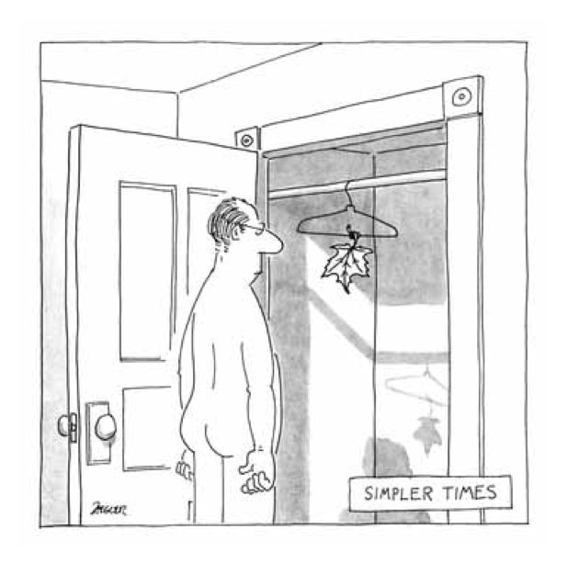
  - Identify your “disaster possessions.” If a disaster happened and you had to leave everything behind but what you could take in a car, what would you take with you? These are the core things to keep – everything else is simply “space available.” Knowing what these core things are will help you sort out the rest. We tend to lose our ability to prioritize when surrounded by too many choices: use this as your key to finding out what is really essential to you.
  - Consider giving away part or all of your inheritance of things now. Are you using the thing or just hanging on to it to pass on when you die? Remember that you need to pass on the meaning/story of the thing, not just the physical substance of it. Make sure the inheritor knows the story.
  - Try to eliminate at least a third of what you have in the first time you sort through things. Of the things that are kept that are not “absolutely I am keeping this,” eliminate at least half of those on the second sorting – and more if you can. Remember that it is better to have one thing you really like than three things that are sort of OK. Be open to replacing a lot of nearly right things with one or two really right ones.
  - Downsizing can lead to treating yourself better, by helping you focus on having fewer things that you really enjoy rather than settling for second best. Let downsizing allow you to more fully and accurately express the you you like to be.

