Memory and Forgetting
Copyright 2017 Larry Moen, M.Ed LPC Uncommon Therapy www.utherapy.net

SESSION 1
- The structure of memory
  - Mental constructs or templates
    - What we pay attention to
    - What we expect to need to pay attention to
    - Priming – unconscious attention
    - Filling in templates – current conditions
    - Filling in templates – associational factors
    - Filling in templates – habitual factors
    - Filling in templates – peer pressure and suggestibility
  - Memory consolidation
    - Signal and noise
    - Associational connection
    - Reinforcement
    - “What fires together wires together”
    - Sleep and memory
  - The re-creation of memories
  - Neurological basis of memory
  - Brain location of memories
  - Types of memory
    - Short-term memory
    - Long-term memory
    - Unconscious memories
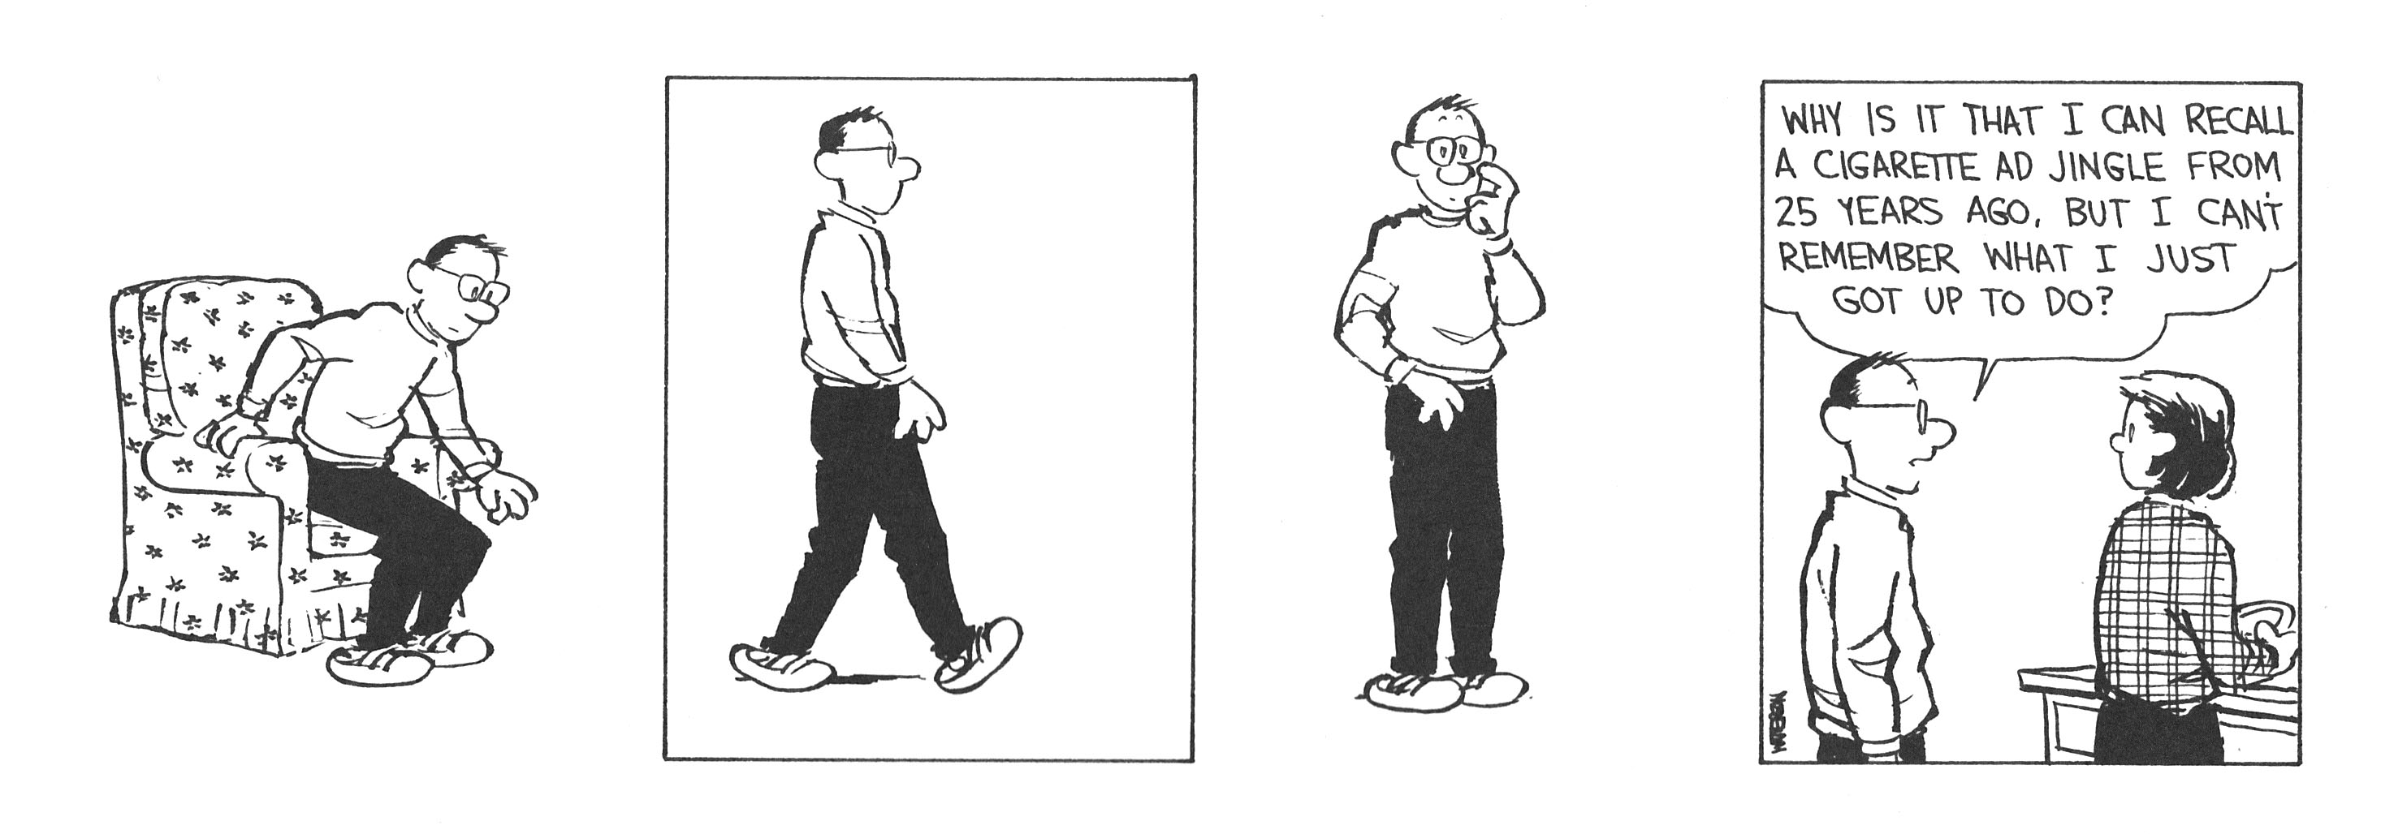
Impeachara ------ https://www.youtu.be/QXUlhT3-r0c

