A Quick Primer on Sleep – Part 1
Copyright 2017 Larry Moen, M.Ed LPC Uncommon Therapy www.utherapy.net

What is sleep?
Despite all the advances in science sleep is still largely a mystery. Clearly it is a crucial process for us (and for all animal and even some plant life) – yet exactly what happens when we sleep is still unclear.
We cannot survive long without sleep – at most about two weeks. We also cannot FUNCTION very long without sleep – lack of sleep begins to affect us within 24 hours, physically and mentally. The mental dysfunctions caused by lack of sleep are more immediate and severe than the physiological ones.
Sleep deprivation results physiologically in increased risk of cardiovascular problems including stroke, arrhythmias, and hardening of the arteries. It also results in decreased immune system functioning, increased weight, increased risk of diabetes, decreased sensory discrimination, and decreased hand-eye coordination.
Psychologically, it results in decreased attention and vigilance, decreased cognitive functioning, a five-fold increase in the chance of having depression, decreased memory consolidation and retention, decreased affect in speech, increased paranoia, increased mild hallucinations, increased accidents and errors, and increased suicide risk.
Yet, despite these profound effects all of the psychological effects and many of the physiological effects can be completely reversed with only a few hours of sleep. The amount of sleep needed to do so is disproportionately small relative to the total sleep deficit. This is amazing stuff – and still little understood.
What we know about sleep, and when we knew it
Until late in the last century sleep was considered to be some sort of “OFF” switch. Consciousness just got turned off, for unknown reasons, so that we could somehow become “refreshed.” People generally made up reasons such as “it gets dark and we can’t do as much, so why not shut things down for a bit to avoid unneeded wear and tear,” or “sleep is a mysterious time of connection with the spiritual world, as evidenced by dreaming,” or “the body is weak and cannot sustain 24-7 consciousness, so it has to shut down every so often.”
In 20th century Western culture, sleep became seen as something of an annoyance: “Look how much I could get done if I just didn’t need to sleep.” The vast preponderance of people in “advanced Western civilizations” get too little sleep, and instead of recognizing their body signals to get more sleep usually try to offset the sleep deficit through use of stimulants (most noticeably caffeine) and by forced regulation of sleep through sleeping pills or alcohol to induce sleep and caffeine to force wakefulness. The saying “sleep is just the absence of caffeine in the body” reflects this attitude, as does the following cartoon:
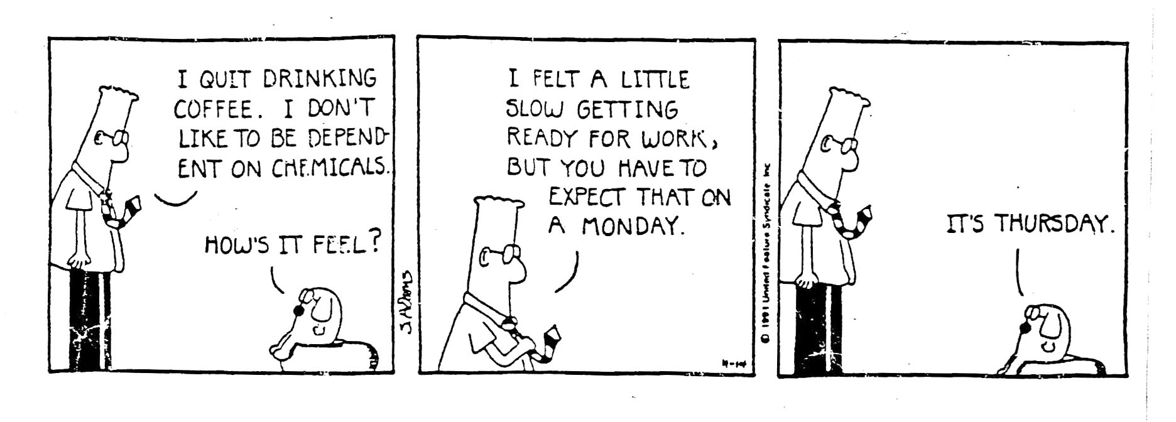
All of this cultural shift regarding sleep patterns was reinforced in the late 20th century by the cheapness and prevalence of artificial sources of light, and the resulting change of work and entertainment being mostly done in daylight hours to the obliteration of daylight as a constraint for most non-agrarian professions. Where once it was expensive to stay up late or a sensory challenge to do so, now not only could everyone afford to do so but the culture shifted to emphasize doing so. We no longer were constrained by the natural cycle of light and dark.
A side note: Prior to this time there is evidence that sleep was decidedly different – there are references to people having “two sleeps” – a period of sleep from shortly after sunset until the middle of the night, then a period of an hour or so of wakefulness (described by sources as often a highly relaxed or even spiritual time) and then a “second sleep” from then until around daybreak.
In the mid-late 20th century all of the changes caused by shift-work, artificial light, and advances in neurobiology and neurochemistry led to research into sleep itself. That research has increased up through the present day.
The architecture of sleep
Advances in the ability to monitor electrical activity in the brains of living subjects has allowed science to discover that sleep is not a single uniform process, but instead is a cycling pattern of four distinctly different states of sleep. When we are asleep we cycle through these four “stages” of sleep in the same basic sequence, but in changing amounts of time devoted to each stage.
Stage 1 Sleep
The first stage of sleep, Stage 1 Sleep, is a state of near-wakefulness. Just as drowsiness is a condition of being “almost asleep,” Stage One is a condition of being “almost awake.” What is the purpose of this stage? Sleep and wakefulness, as discussed later, appear to be the result of two different brain systems, one that promotes being asleep and the other that promotes being awake. The nature of the interaction is that the only stable choices are asleep or awake – there isn’t any sustainable third choice of some mix of both (or at least current science doesn’t believe so).
If we fell immediately into deep sleep we’d have a result that mirrors what happens to people who have narcolepsy. These individual go from being awake to being asleep in seconds. Those that have trouble falling asleep might see this as something desirable, but the experience of narcolepsy is highly dysfunctional. Particularly when under stress, the individual’s brain triggers a sudden release of the neurotransmitters which induce sleep, and they fall asleep instantly regardless of what they are doing – talking, standing, driving a car, whatever. They collapse into sleep. Clearly this can be dangerous in many ways.
Stage 1 sleep provides a much better transition, and that seems to be its main purpose. Typically it is the briefest stage of sleep, lasting only a few minutes. As it cycles around during the night it allows the sleeper to be for a brief time more aware of his or her situation and more able to awaken if circumstances make it necessary.
Individuals who have frequent awakenings during the night typically wake up when they are in Stage 1 sleep.
This isn’t always true. Sometimes a person will awaken from a “deeper” stage of sleep. These awakenings are jarring and stressful. One form of these is the startle awakenings” common to PTSD and other conditions of high stress. Another form is awakenings from nightmares. A third form is that of awakenings characterized by confusion as to which is reality – the dream state of the awake state. Yet another form is that of intense sluggishness, an inability to come out of deep sleep easily.
Stage 1 sleep allows us a much smoother transition in and out of sleep.
Stage 2 Sleep.
Not a lot is understood about Stage 2 sleep. Because of that, it has been largely ignored, probably inappropriately so.
In all the stages of sleep our brain waves – the patterns of electrical activity in our brains – change into distinctly different constellations. In Stage 2 sleep short activity bursts called sleep spindles occur. Sleep spindles seem to have some correlation to IQ – the more sleep spindles you have in the same period of time, the higher your IQ (on overall IQ and performance IQ, but not on verbal IQ). However, persons with learning disabilities also have high sleep spindle densities, so what this all means is still unclear.
What does this sleep spindle activity accomplish? Why do we need this stage? Science has no answers as yet, so unfortunately neither do I or you, and we must move on to the next stage, which has received perhaps the most attention of all. In fact Stage 3 Sleep has gotten so much attention that now some researches lump Stage 1 and Stage 2 into it and call the whole first three stages just “Non-REM Sleep.”
Stage 3 “Slow Wave” Sleep
Stage 3 sleep is also called “slow wave” sleep because it is characterized by repeating slow patterns of 0.5-4.5 Hz frequency (“low frequency”) brain waves called Delta Waves. I’m going to abbreviate Slow Wave Sleep as SWS (instead of S3) below, since that is the name most commonly used for it.
SWS appears to be the most crucial process of sleep. How do we know that? If we get short on sleep and then have an opportunity to “catch up” on sleep, our brain will quickly go to Slow Wave Sleep and spend most of its time in that state. This is the only stage of sleep that works that way. All the other stages don’t require any special “catching up,” but SWS does.
Curiously, when we make up a sleep deficit we don’t need a one-for-one time to do so – if I’m 8 hours short on Slow Wave Sleep I can be fully recovered in far less time. There’s as yet no good explanation for why that is so, although we’ll discuss a possibility a bit later on.
Slow Wave Sleep is restorative sleep. If you have had 8 hours of sleep (or whatever amount is normally restful for you) and still wake up unrefreshed, the problem is almost certainly that you have not spent enough sleep time in Slow Wave Sleep.
So what is happening to cause this? Why is this the most crucial process during sleep? What does it mean to feel “unrefreshed”? Once again, he answers are somewhat sketchy. Here’s what we do know:
Sleep and Memory
Slow wave sleep seems to be crucial for establishing memory. Modern science, wishing to avoid the atrocities of Nazi-era medicine, elected the slightly-less atrocious technique of cutting open living rats’ brains and implanting electrodes to measure their brain activity while they were doing various tasks. What they found was that when these rats slept, their brain activity in SWS matched the brain activity doing the tasks they did when awake – essentially, they were replaying what they had done during the day. Only they were doing this about 7 times faster, and doing it over and over again during this stage of sleep.
Why?
What appears to be happening is a sort of “separating the wheat from the chaff” or “determining signal from noise” process. After even short periods of sleep rats – and people (including people who may also be rats) – perform the tasks they learned that day better.
If you will, this is a part of what we mean by “learning”– the process seems to ask these kinds of questions: What is part of the pattern and what isn’t? What can I ignore, what do I not have to do, what should I look out for? All these sorts of questions get answered. Biologically, the synaptic connections for those things get reinforced, and the synaptic connections considered unimportant get diminished or repressed.
So -when you sleep you get smarter.
Memory and learning are sometimes difficult to separate from each other, but let’s try a bit. This process also works to identify what parts of my between-sleeps experiences I choose to identify as important or meaningful, and then to strengthen the synaptic connections regarding those while repressing the others. Memories become “sharper,” just as tuning a radio increases the clarity of the signal and decreases the static or noise.
How does our brain decide what is important to learn or to remember? The short answer is – let’s not go there right now. Because the long answer is long, and we want right now to stay focused on sleep.
Associational Thinking
I am absolutely convinced that modern psychology hasn’t yet fully understood the power and nature of associational thinking. I am also convinced that what Slow Wave Sleep is doing is revisiting our experiences over and over again to cull out/identify associations with the previous patterns we’ve identified in our lives.: to me this is the best explanation for why we not only “re-experience” things, but do this again and again in SWS. I think that on each “pass” our brain is focusing on different things in the experiences that connect – associate – with what we’ve already decided it was important to learn or remember.
This is crucial for memory in many ways. We need “handles” to retrieve memories – dates, times, sensory input (e.g. “blue things”), concepts, emotional content, etc. etc. Much of what we call intelligence is our ability to find and label (consciously or unconsciously) connections and/or patterns between a wide variety of things. That’s also the basis for creativity. Trying to store memories any other way would be like having a photo album with millions of pictures and no index.
As we have learned in this “information age.” It isn’t as much about having a lot of information as it is to finding ways to efficiently access the data you need, and to verify that it is real or true (Thank you, President Trump, for reminding us of that crucial aspect to things!)
I believe that during SWS our brain is hard at work creating this web of connections between our most recent experiences and those of the past.
Clearly this is a crucial function that needs to be done, and sleep is an ideal time to do so because we are not adding in – and having to deal with – new conscious input. While it’s true that we do some of this associating during the day, the amount of “processing” needed is tremendous. This might also help explain why babies – who are attempting to associate together enormous amounts of brand-new information – need far more sleep than adults, for whom there is typically more redundancy or similarity is experiences than novelty. It may also explain why trying to absorb a lot of new information – through learning or through some intense experience – often leaves us craving sleep.
Feeling refreshed
I think there are two components to feeling refreshed after a good night’s sleep. One is physical – and that may be largely mechanical in nature. Like the old ideas about sleep, yes, it is important to give a tangible machine, even a biochemical/biophysical one, downtime enough to let its restorative processes get more attention and resources. We know, for example, that lack of enough sleep compromises our immune system and slows healing.
I think that SWS also helps us feel refreshed by, if you will, sweeping out the clutter, the unimportant details our brain has absorbed during our waking hours that it is reluctant to let go of until the good stuff has been identified and stored away. The SWS process leaves us with sharper and clearer thinking and, I believe, a sense of satisfaction that we have done with these experiences what we needed to and are ready to take on the next set. If that hasn’t been done then we either have to add on the burden of still more experiences to process, or risk letting go of important things when we “throw the baby out with the bath water.” Neither sounds like it makes for a happy mind.
Moving on: Stage 4 (REM) Sleep
REM sleep is markedly different from other stages/processes of sleep for two very distinct reasons. The first is what gives this stage its name: REM, or Rapid Eye Movement. During this stage of sleep your eyes start darting back and forth beneath their lids. Why? Well, we just don’t know. BUT we’ll hazard a guess in a moment.
The other striking characteristic of REM sleep is something called sleep paralysis. Sleep paralysis is pretty much what it sounds like – during this stage of sleep your brain disconnects your thinking from your ability to move the muscles in your body. Every time you go into REM sleep you experience a kind of near-total paralysis.
OK, let’s assume your brain does not nightly flirt with the idea of immobilizing and killing you – what could this possibly be for? The answer is actually pretty simple. REM sleep is when we do most (but not all) of our dreaming. When we dream we often envision ourselves doing things – all sorts of things, from walking, talking, brushing our teeth, even perhaps murdering those horrible in-laws we have. Our muscle system and all the movement centers and structure of our brain and nervous system cannot tell the difference between these dream-based decisions to move around and do things and our awake and conscious decisions to do so. So if we don’t shut that system off during this stage of sleep we will act out whatever it is we dream we’re doing.
And people who have some sort of dysfunction in initiating or maintaining sleep paralysis do indeed do just that – up to and including murdering people. Fortunately most cases involve talking in your sleep or sleep-walking. But sleep-eating and sleep-sex are not totally uncommon. These are all known as parasomnias, and are fascinating but very fortunately pretty rare, especially the most destructive forms. It seems likely that, just as we rarely think of actually killing someone in our dreams, in the vast majority of cases our brains can awaken us before we engage in such extreme behaviors.
Which brings us back to two questions: what purpose does REM sleep serve, and why do we dream?
My belief about the purpose of REM sleep
OK, let me start by saying that, in general, science hasn’t yet come to any good consensus about either of those two questions. I’m going to leave discussion of dreams for another paper and another time, because it is another of those Really Big and Controversial Questions. In fact there is currently no universally accepted definition of what dreaming is. So we’ll move on to asking: What else does REM sleep achieve?
There are a couple of good possibilities. There is some evidence that during REM sleep the emotional content of experiences is blunted – the emotional content is thus easier to look at and process. REM sleep might be allowing us to sift through the emotional, rather than the practical, aspects of our last waking period.
One evidence of this is what happens to something called the “Weapon Focus Effect.” When we first encounter a situation with an intense focus, like seeing a person with a gun or a bloody knife, we tend to get so focused on the weapon that we are unable to provide many details about the person holding it (or much of anything else). After we sleep, however, we often can recall accurately other details that initially were overwhelmed by the emotional focusing. In this case our later recall is actually better than our initial one. So in the cop shows when the investigator gives the witness his/her card and says “Call me if you remember anything else” there is validity in that – provided the person calls after they’ve had some sleep.
Dreams may give us a clue to another possibility of what goes on in REM sleep: dreams seem to combine existing knowledge, images, and experiences (or attributes or associations regarding those) together in novel and unexpected narratives. We know that sometimes sleep allows us to discover new connections we previously were unaware of. Rats who sleep sometimes seem to discover new pathways through mazes; humans in sleep can develop new shortcuts to handling tasks. There are also many anecdotes of inventors, scientists, artists and others coming to “aha!” moments of new understanding during or just after dreaming, Neils Bohr’s model of the structure of atoms and Coleridge’s Kublai Khan poem being two well-known examples. I think it possible that REM sleep is the stage in which our associational thinking actively investigates creating new associational links between existing neural networks.
(But maybe Stage 2 sleep does some of that – we just don’t yet know for sure.)
As to the rapid eye movements themselves – perhaps emotions are more tied to our visual sense than to others… except even blind people have REM. It remains a mystery.
How do these four stages of sleep progress during a night of sleep?
The four stages repeat in the same sequence in cycles lasting, usually, 45 minutes to an hour. Eight hours sleep would yield about 8-10 complete cycles. When we first fall asleep we spend much more time in SWS than in REM sleep. By the end of the night this has reversed, with shorter SWS and longer time spent in REM. If you are awakened in REM sleep you are more likely to remember your dreams, but you are also more likely to be disoriented than if you wake from Stage 1 sleep and have a harder time “breaking free” from your dream.
What else do we need to know about sleep architecture?
Dysfunctions can occur in any of the stages of sleep. The most impact on psychological and physical well-being seems to happen when SWS is missing or disrupted, but the parasomnias associated with REM sleep can have major impacts as well. Narcolepsy and startle awakenings also make life difficult. Only disruptions to Stage 2 sleep have unexamined consequences, although it would seem foolish not to assume that dysfunctions here would also have significant consequences similar to those of the other stages.
There are other aspects of sleep architecture that we will explore later as those relate more to specific topics than to general sleep structure.
What regulates sleeping and wakefulness?
As mentioned earlier, we appear to have two separate systems at work in our brains, one that induces sleep and one that induces being awake. These are triggered by two primary factors, one internal and one external. Internally we have a kind of internal clock that keeps us on a repeating pattern of wake and sleep which is about 24 hours long. Intriguingly, it is NOT 24 hours, but about 24 hours and 30 minutes for most people. This system is referred to as our circadian rhythms.
The second major trigger is that of light and dark. Light, and particularly daylight, acts to reset our internal circadian rhythms and keep them in synch with our outer environment.
Without the cues of natural light our days drift off-kilter to actual days: in experiments where subjects are kept in environments that are always lighted or always dark those subjects quickly change to later and later awakenings and consequently after several weeks believe that fewer days have passed than actually have.
We will explore the consequences of the impact of light in greater detail in the next paper on sleep. Making adjustments to light –and the specific kind of light – can make significant differences in the amount and quality of the sleep you get.
During normal daylight, and particularly after noon, the “awake” system is flooding our brain with acetylcholine and other neurotransmitters which create wakefulness. During the day the “sleep system” provides increasing amounts of GABA and other neurotransmitters that create sleepiness. At a certain point these neurotransmitters have increased enough that they “flip the switch” from wake to sleep. The process is reversed when we move from sleep to awakening.
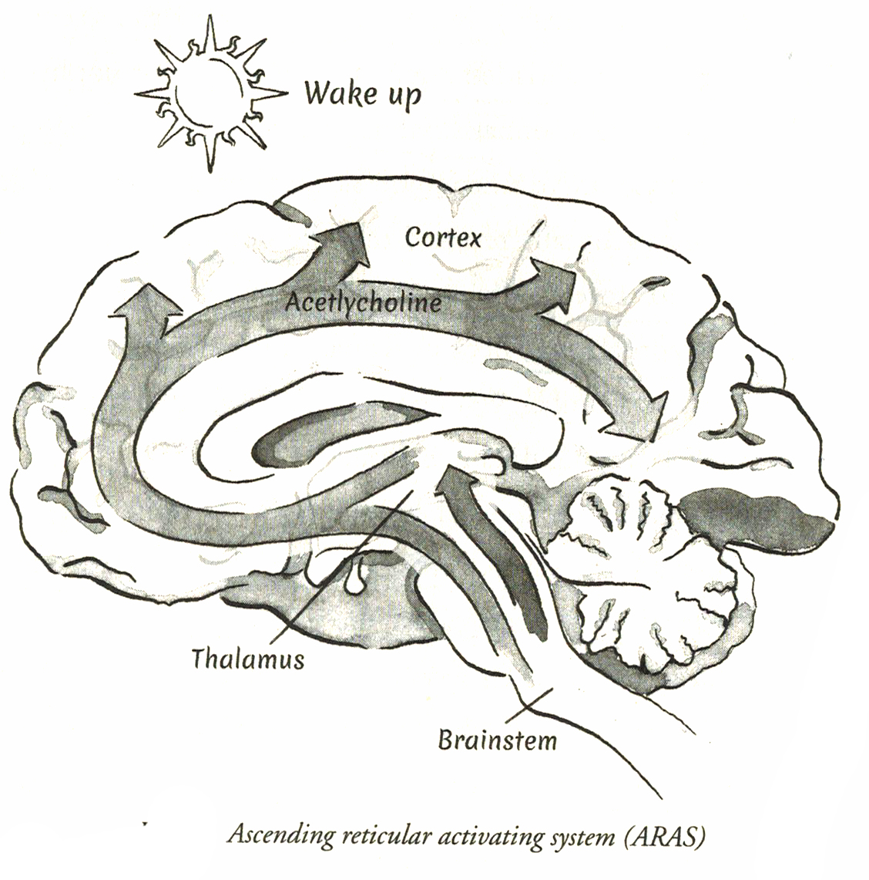
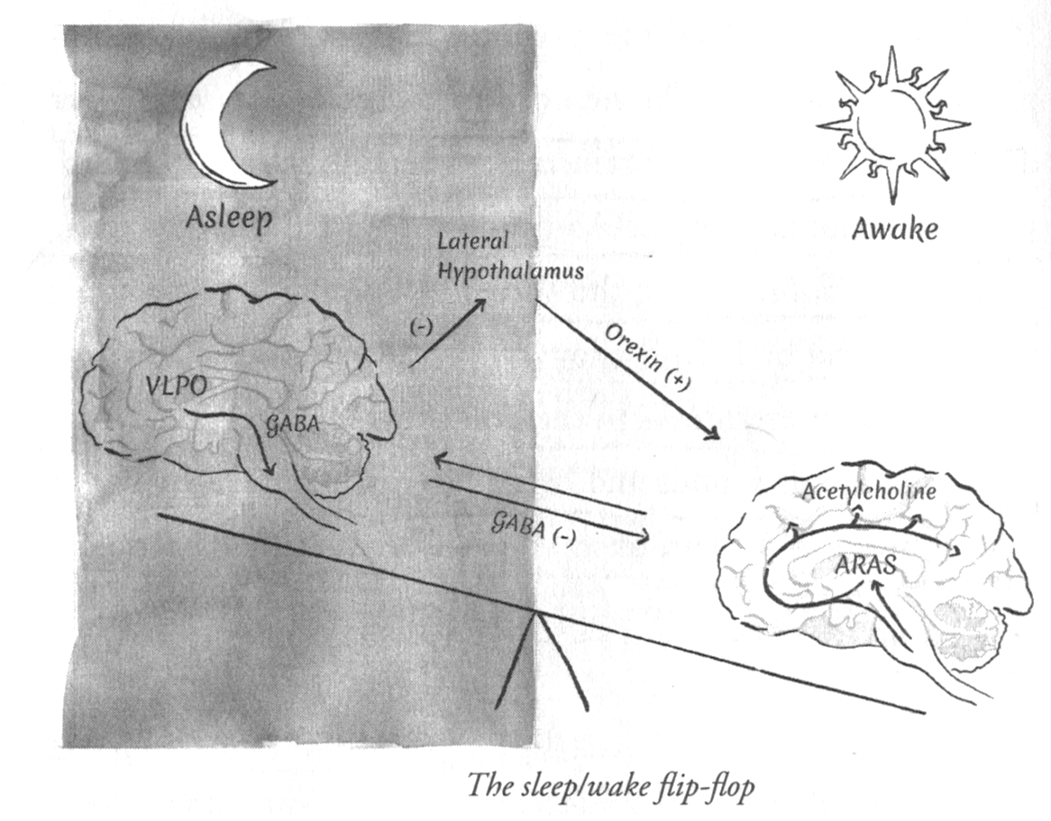
Sleep problems occur when we things occur which interfere with this normal circadian cycle. Illness, stress, or, importantly, the things we do can affect the levels of neurotransmitters, enhance or block their effectiveness, or confuse one or both systems.
Sleep changes throughout the lifetime
The chart below shows the changes in the amount and type of sleep that are typical throughout the lifespan.
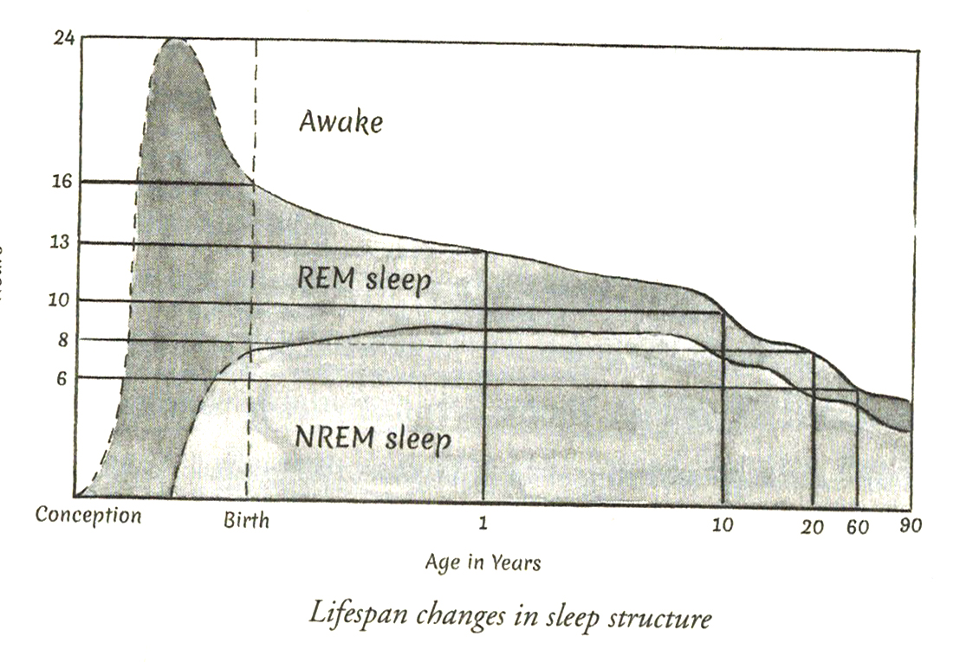
As mentioned before, one possible explanation for these changes is the amount of novel information that needs to be learned, remembered, or otherwise associated. The more patterns we recognize, the fewer we have to create. The stronger the patterns we have created, the less new information is likely to significantly alter them. This all argues for less time needed in SWS and REM sleep.
However there are other factors which clearly play a part as well. Aging increases the risk of chronic pain, both physical and mental. Medications used to treat age-related illnesses are often sleep-disrupting. Bladder and other issues increase, causing a need for more awakenings.
Despite all these causes and surmised causes it is still not definitive why we sleep less when we get older: there may be other factors involved which we are currently unaware of, and which may be more important than the ones we see now.
Its also unclear – if we got more SWS later in life, would our memory be better? (SWS can be initiated to some extent by when you nap during the day – afternoon naps are more likely to induce SWS than are morning ones.)
Conclusion
All that said, more satisfying sleep can be achieved at any age, and that will be addressed in the next paper.

Copyright 2017 Larry Moen, M.Ed LPC Uncommon Therapy www.utherapy.net

