A Quick Primer on Sleep – Part 2
Copyright 2017 Larry Moen, M.Ed LPC Uncommon Therapy www.utherapy.net

Sleep disorders
Recently sleep disorders, particularly sleep apnea, have become much more diagnosed than in times past. Whether this is because of a greater importance attached to sleep or because the diagnostic costs make exploring this highly lucrative is difficult to ascertain. Let’s take a brief look at a fairly complete listing of the most common sleep disorders.
Chronic insomnia
By far the most common sleep disorder is chronic insomnia. It is normal to have an occasional night or two of insomnia due to stress, body discomfort, or inadvertently messing up circadian rhythm patterns. Where insomnia typical becomes an actual disorder is when it becomes chronic. Chronic insomnia is defined as difficulty falling asleep or maintaining sleep 3 or more times a week for at least 3 months. It is estimated that about 10-20% of the adult population of the United States are currently experiencing chronic insomnia.
Chronic insomnia typically gets treated through the prescribed or non-prescribed use of sleep medication. Despite the multimillion dollar ad campaigns touting these sleep medications, medication is by far not the best treatment for chronic insomnia. It is, however, a multi-BILLION dollar business, hence the advertising. It is also an easy fix for a medical doctor to prescribe.
This is an important factor because the actual best treatment option defined by the National Institutes of Health and many others is CBT-I, Cognitive-Behavioral Therapy for Insomnia. CBT-I is best provided by mental health therapists trained in CBT. Most doctors do not make referrals to mental health providers, and certainly do not get paid for those referrals, whereas sleep medications mean a return office visit sometime in the future.
I’m probably being overly cynical here, but the truth of the matter is that neither medical health providers or mental health providers do nearly enough referrals to each other. Repeated research states that at least a third of medical doctor visits are actually due to mental health conditions. On the other end, many things that look on the surface to be mental health problems actually have physical health causation, including environmental allergies, genetic disorders, and drug interactions.
CBT-I
Nevertheless, CBT-I has been shown in repeated studies to have a minimum 80% cure rate, without side effects, and with little later return of symptoms – all things sleep medications can only envy but fall far short of replicating. We’ll further explore CBT-I in another paper.
Here is a chart of the most commonly used sleep medications and their recommended length of use. In the third companion paper, A Quick Primer on Sleep – Part 3, we’ll discuss other non-medication approaches for treating insomnia.
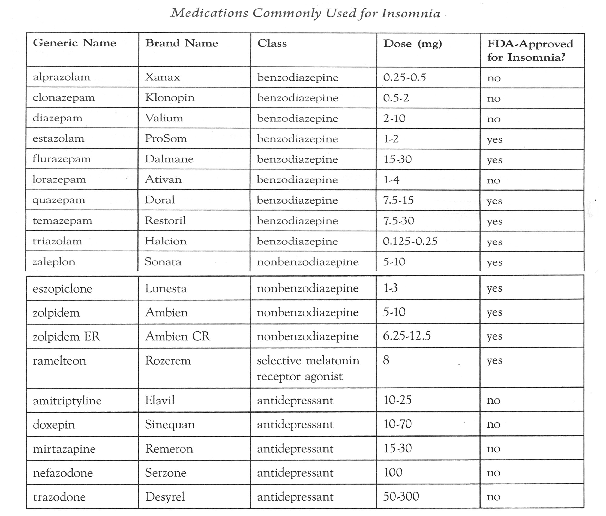

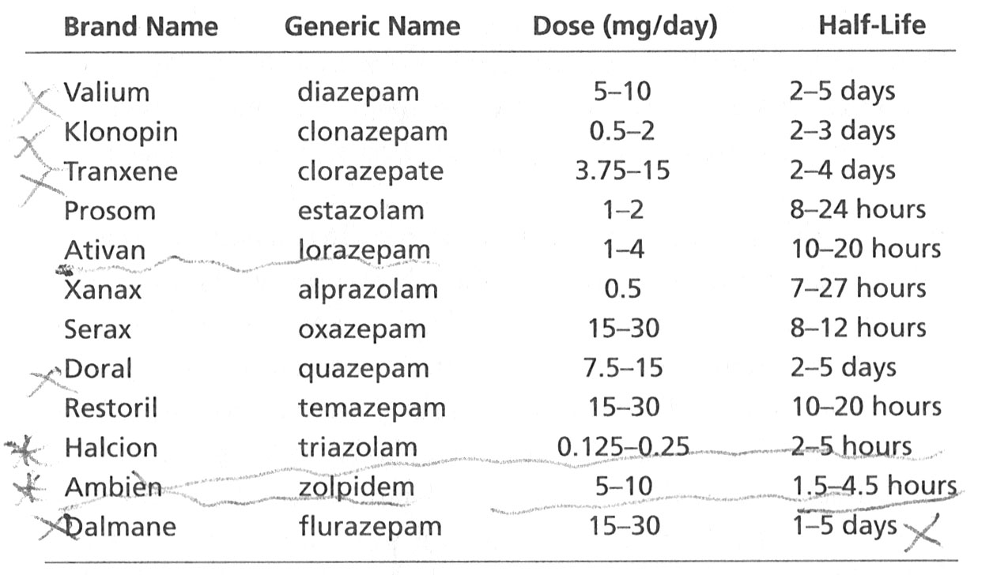

Sleep Apnea
The second most common sleep disorder is that of sleep apnea. During sleep apnea a person stops breathing while sleeping, and experiences a semi-awakening state to start breathing again. This can happen up to over one hundred times an hour. Moderate sleep apnea begins at 30 times an hour.
Two factors can cause sleep apnea. The first is a result of physical dynamics in the airway. This is Obstructive Sleep Apnea. As muscles slacken in sleep tissues and structure in the throat and neck move such that the airway becomes blocked. The most common treatment is a dental device for mild sleep apnea that changes the positioning of the jaw when asleep, or a machine that provides continuous air pressure in the nose and mouth for moderate and severe sleep apnea. The air pressure acts to keep the airway open.
The second kind of sleep apnea, Central Sleep Apnea, is neurological – a malfunction in the brain wherein the brain periodically neglects to send the neurological signals for breathing. This kind of apnea usually requires medication for treatment and the uses of CPAP-like machines.
Restless Leg Syndrome
Some people experience a condition where when they are attempting to sleep and when they are asleep they have periodic limb movements. RLS is the most common form of this. A person with RLS will have involuntary leg movements accompanied by uncomfortable sensation deep in the legs. The sensations may be tingling, itching, burning, “creeping/crawling”, or some combination of these. Some RLS is caused by sleep apnea. Most RLS is treated by medication.
Circadian Rhythm Disorders
Two disorders relate to an inability to sleep at a normal time, regardless of other circumstances. These are called Delayed Sleep Phase Syndrome (“night owls” who typically go to bed between 1:00 and 4:00 AM) and Advanced Sleep Phase Syndrome (“larks” w2ho typically go to bed between 6:00 and 9:00 PM and arise between 4:00 and 5:00 AM). The evidence strongly supports that this is a genetic issue: one gene has two “toggle switches’; if both are in position A the result is a “night owl”, if both are in position B the result is a “lark”, and for most people one is in A and one is in B resulting in “normal” sleep patterns.
Circadian rhythm disorders are usually treated with a combination of micro-dose melatonin and light therapy.
Jet-Lag Disorder and Shift Work Disorders are sometimes included in this category.
Non-24
Recently we have started to see national media advertising for medicine to treat Non-24 Disorder. This is somewhat perplexing because this disorder is extremely rare and confined to a small portion of those who are blind. Basically some blind people start to drift away from a 24-hour day and need to be brought back into synch. New medications are used to address this.
Parasomnias
As was briefly mentioned in the companion paper, parasomnias are any and all of the manifestations of behaviors that occur when something prevents sleep paralysis from engaging. The most common parasomnias are sleepwalking and sleeptalking. For unknown reasons children about age 3 ½ show an uptick in these behaviors; almost all these children self-recover in short order and never experience the symptoms again. (There is some possibility that these result from the body adapting to changes in expected bladder and bowel control; a child may semi-awaken in order not to wet or soil the bed, and sleep paralysis become disrupted during the period of time the body is adapting to this changed regimen.) Other parasomnias include night eating and sexsomnia.
REM Sleep Behavior Disorder
Most common in men after age 60 and people of both sexes with PTSD, RSBD involves a period of muscle movement (up to searching or escaping patterns of movement) and/or vocalizations, is sometimes violent, occurs later in the night during REM sleep, and is done in reaction to exceptionally vivid dreams. Causation is unclear but in 30-40% of cases RSBD is followed in later years by neurological disease, often Parkinson’s.
Sleep disorders and the internet
There is an amazing amount of information available on the internet regarding sleep disorders. If you have a further interest or concern regarding one or more of these disorders you will find screening tools and further information about each disorder easily available.
Sleep Hygiene
Sleep hygiene is the name for a set of behaviors done in order to establish patterns of behaviors and choices which support good sleep. The three main areas of focus are: 1) ingestion of food and other substances which affect the sleep and wake systems and their neurotransmitters, 2) optimizing the sleep environment, and 3) establishing habits of behavior which condition the body to sleep when in bed.
Some substances we ingest such as nicotine, alcohol, and caffeine directly affect the sleep and wakefulness systems. Additionally, the digestive process can disrupt sleep when too much food is eaten too close to bedtime.
The sleep environment is also a prime determinant on the quality of our sleep. A dark, quiet environment that is cool but not cold and which contains sufficient negative ions is important. Likewise other aspects of the environment (comfortable mattress, lack of clutter in the room, etc.) also can affect the length and quality of your sleep.
Third and finally for sleep hygiene, establishing regular habits can be crucial in the body and mind’s regulation of sleep. These topics are addressed in the attached articles, and will be further discussed in the last of these three papers.

Copyright 2017 Larry Moen, M.Ed LPC Uncommon Therapy www.utherapy.net

