A Quick Primer on Sleep – Part 3
Copyright 2017 Larry Moen, M.Ed LPC Uncommon Therapy www.utherapy.net

Strategies for better sleep
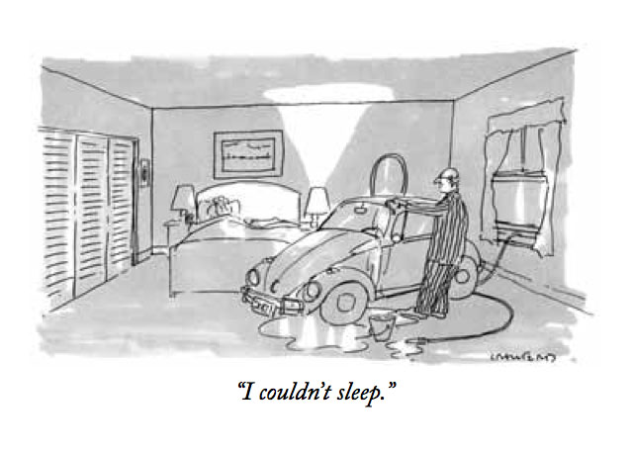In addition to the standard procedures itemized in sleep hygiene, there are other helpful practices one can use to get better sleep.
To better look at those, let’s see how they fit within the process of sleep.
Wakefulness
When we wake we need to reset our circadian rhythms from 24-hours plus back to 24 hours. Getting daylight or its equivalent when first we awaken is a key to that. We have “blue-sky” receptors in our eyes which seem to be there specifically for this function. Getting bright light right after you awaken (at the time you want to wake up) is crucial. Getting outside, even if only for a few minutes is best. A light box is the second choice. Bright indoor lights are better than nothing, but remember that even the strongest indoor lights create the brightness of dusk, not daylight.
Naps
After awakening our GABA and other sleep neurotransmitters begin their process of gradually building up. We want them to continue to do so. Napping acts to offset the normal buildup of these neuro-transmitters, so we want to avoid naps in general. However, naps of 20 minutes or less do not seem to have a significant impact on sleep unless they are taken in the 3 hours before you normally go to sleep for the night.
Also, human beings have a slowdown that happens early in the afternoon – the “siesta time”. Perhaps just as we once had “two sleeps” at night we also had “2 wakes” each day. Although most sleep information is absolutely against any naps, my own belief is that a daytime nap, particularly at “siesta-time” is restorative and unlikely to affect falling asleep at night.
Naps taken earlier in the day tend to have longer periods of stage 3 sleep, while those taken later in the day have longer periods of REM sleep. If you need to feel more “restored,” nap early. If you need to process emotional issues or tap your creative thinking, nap later.
Darkness
When darkness comes it triggers a change in neurotransmitters, reducing wake compounds like acetylcholine. Our bodies start to release release small amounts of melatonin. You can assist this process in several ways. Most electronic devices and some newer light bulbs produce blue light, which confuses our blue light receptors into thinking it is still daytime and that in turn affects the neurotransmitter balance. Either reduce your use or seek out either apps or yellow sunglasses in order to cut the blue light to your eyes. You can also take additional melatonin, but 1) this must be taken two hours prior to your intended bedtime and 2) you should take a dosage of about 0.1 mg, not the dosages found in almost all current supplements. Because our bodies react to light and darkness, bedrooms should generally be as dark and “night-like” as possible.
Cold and Exercise
It also usually gets colder as the night progresses. One thing that triggers sleep at night is a drop in body temperature. You can induce this in many ways – turn the temperature down an hour or so before bedtime, go outside just before bedtime (if outside is cooler) for a few minutes, or take a bath (or otherwise raise your body temperature) for at least 20 minutes ending about a half hour before bedtime. After the bath your core body temperature will drop, signaling its time to sleep. This is also the reason its recommended that the temperature in your bedroom be cooler than that in the rest of your house.
Exercise is generally not recommended right before sleep – but if it leaves you physically and mentally tired and leads to elevated core body temperatures that then fall, it might just work.
Noise
During the night your unconscious needs to be in control. It will monitor your environment and wake you up if anything too unusual is going on, especially if the unusual thing is happening when you are in stage 1 or stage 2 sleep. This is part of the reason why a person who awakens frequently during the night is more likely to do so about every hour. To prevent this, it is helpful that whatever noise is happening during the night is uniform or highly predictable. The sleep experts say “no noise,” but I believe that’s overly limited. Just make sure that whatever noise is present is bland/uniform/predictable. You can get a “white noise” generator to help mask outside noise if noise outside your bedroom is intrusive and unpredictable.
Mattress
Research has shown no correlation between mattress hardness/softness and better sleep. Individual preference as to what you wear to sleep and what you sleep on outweigh any across-the-board considerations.
Habit
In addition to all of the environmental cues, you can – and should – use a wonderful tool called habit. Establish a set bedtime ritual, and follow it as much as possible. This is the thinking behind many of the sleep hygiene suggestions/rules. If your bed is used only for sleep or sex, going to bed cues your brain to expect to do one or the other. Or both. (Maybe that’s part of why some people get sleepy after sex.) If you don’t have a ritual, or don’t stick by it, your brain says –“Hey, we’re still having to make conscious decisions about things; we can’t let our unconscious take over.” Anything else you can use as a tool to enforce a habit of “it’s time to sleep” is helpful, except anything mentally or physically stimulating – unless the stimulation results in an immediate state of relaxation.
The habit angle is why the recommendation is to get up if you haven’t been able to fall asleep in the first half-hour or so after going to bed. The idea is that you want your brain to associate being in bed only with being tired and ready to stop consciously thinking. It’s better to get up and do something non-stimulating until you feel tired, then return to bed at that time.
Insomnia
If you can’t fall asleep as fast as you want – you have insomnia – or you wake up during the night, try to accept it. Becoming anxious or frustrated is normal, but let that go as quickly as you can. Avoid thoughts related either to “well this is going to make tomorrow terrible/difficult/harder” or “oh no, not THIS again – what’s wrong with my brain; I need to SLEEP!” These are the kind of thoughts that lead to chronic insomnia. Anxiety or anger about not sleeping actually acts as a cue to your brain that says “Hmmm… we’d better consciously think about this – this is unusual and might cause us trouble, so we better not drop off.” One part of the CBT-I treatment for chronic insomnia is teaching people how to stop having these thoughts.
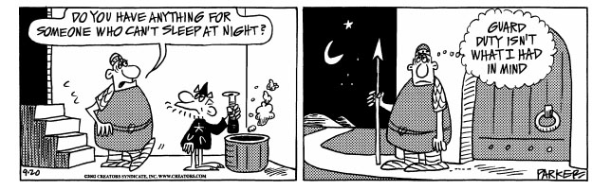Remember that your brain is trying to do the right thing for you – it doesn’t deliberately try to mess you up. If you work with it you have a far better chance of getting the result you want than if you get into an adversarial relationship with it. Much like the legal system, it’s better if you resolve this amicably.
Eventually the sleep system’s neurotransmitters have accumulated enough that they “flip the switch” from wakefulness to sleep.
Sleep stages revisited
As we discussed in the previous companion papers, during sleep we first have a phase that transitions us into sleep, stage 1 sleep. This prevents us from the problems we’d have if we suddenly became unconscious. We then progress through stage 2 sleep (which does something but we don’t yet know what) and get into stage 3 slow-wave sleep which acts to make us feel restored physically and mentally. Next we go into REM sleep, which may be providing us with emotional processing and free-associational thinking. After REM sleep we go back into Stage 1 sleep and the cycle starts over again. Each sleep cycle is typically 45 minutes to an hour in length.
At some point, usually after 6 or more hours of sleep (6-8 cycles) the neurotransmitters of the awake system have built up to where they “flip the switch” again and cause us to be awake. Ideally this happens during stage 1 sleep so that we transition easily from sleep to wakefulness.
Wake-up time
One thing all the sleep researchers agree upon is that you should have the same wake-up time every day, seven days a week. Why? I think this has to do with stage 1 sleep. Your brain wants you to wake up after the end of a sleep cycle; after REM sleep is done and stage 1 has started. This is the gentlest and easiest transition from sleep to wakefulness,
How is your brain going to accomplish this? By knowing, unconsciously and habitually, what time it needs to have you in stage 1 sleep for getting up. If that’s the same time every day, then your sleep cycles can be tailored to fit. If it varies, then either your brain will wake you up too soon or too late, or your alarm (or whatever else wakes you) may well wake you straight out of slow wave or REM sleep, causing disorientation or sluggishness.
So as much as possible, get up at the same time every day. If you didn’t get enough sleep, go ahead and nap later (just not TOO much later).
The nature and purpose of insomnia
Insomnia is a natural response to times of stress and/or danger. If we absolutely have to figure something out or get something done, or we absolutely need to stay awake and vigilant to deal with some danger, we want to stay awake and not lapse into unconsciousness. (Do we ever lapse into consciousness… or lapse into anything else?)
Sometimes our brain has a hard time deciding whether to sleep or have insomnia. When anxiety or pressure to act or figure something out are running high, or we’re in some kind of danger, insomnia is going to seem to be the answer. However, our conscious thinking may be saying “No – I can’t figure this out, or I can’t act on this right now, or there’s nothing to be done right now to make the danger less: it’s OK to go to sleep.”
So why doesn’t that work? Why can’t our consciousness override our unconsciousness the way we think it is supposed to?
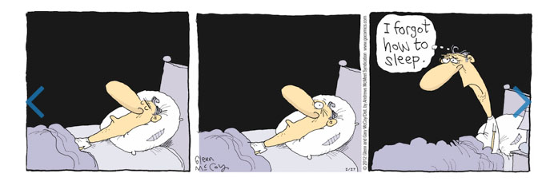
Sleep patterns versus unconsciousness
This may look familiar as a problem. Why can’t we just consciously decide to eat better and exercise more and have that happen? Why can’t we just decide to stop that bad habit of (whatever) and watch it easily go away? Even though we identify who we are with our conscious thinking, that’s just not how it works. Most of our thinking and decisions are done unconsciously.
So what’s the problem here? After all, we want to be unconscious! Unfortunately our unconscious wants us to be conscious. So, often times, we are, I believe, sort of both. We are consciously aware of our unconscious thinking, but not consciously in control – not able to choose to be fully unconscious.
Our unconscious seems to accept that we want to cede conscious control over to our unconscious, so it takes control and starts to run the patterns it does when we’re asleep. Whenever our unconscious is running strongly entrenched patterns – and sleep processing has to rank in the top 10 if not the top 3 -- the unconscious stops listening to what our conscious mind wants until the pattern is completed. So it is running our normal sleep patterns – and ignores our conscious desires/demands, in this case that it shut off our conscious thinking. The result is very much like like “lucid dreaming”– a strange hybrid state where we consciously watch our unconscious at work.
The net result is what we see as rumination, going over and over the same thoughts, experiences, feelings or events --because that’s what our unconscious does during sleep.
What to do about it? Probably the best, although paradoxical, thing to do is to become fully awake. We need to regain conscious control. This at least gets us back into only one state of sleep and wake operating, not both at the same time. The tricky part is that falling asleep is under unconscious control. We can no more fall asleep on command during the day as we can when we have insomnia.
What we need is to get our unconscious to find a “falling-asleep pattern” that will over-ride the current one. Initiating cues that trigger memories of safe, secure, untroubled sleep can work. (Actually, counting sheep was once such a reminder – a pattern of pastoral calm and security.) This kind of re-set is crucial – there is little you can consciously do to change things as long as the pattern of insomnia is playing out by your unconscious.
We can, however, also deal with the situation before and after it happens. What we will need to do is what we do with all unconscious patterns that have become dysfunctional – ensure that if the unwanted pattern starts the unconscious will give us back conscious control (and accept our conscious decision of what to do). We can set up before sleep a pattern that will conflict with insomnia and cause our brain to seek out a conscious choice on whether to fall asleep or stay awake. We can seek to get into a fully asleep pattern before the insomnia pattern can get started. We can re-train our brain by giving it feedback after every time it erroneously uses the insomnia pattern, to better train it when to user this tool and when not to do so.
Many of these issues may benefit from professional help. Much as I try in these papers to state things such that psychotherapy is not needed, sometimes it is – which is good, because without people needing it I’d be financially destitute and unable to write these papers,
In conclusion
If you’ve read all three of these papers on sleep, I hope you’ll find it as fascinating a subject as I do. It is still rather amazing that at this late date in our scientific progress so many things about sleep remain mysteries. I hope these papers have helped to explain some of what we’ve learned so far and that you have found them useful.
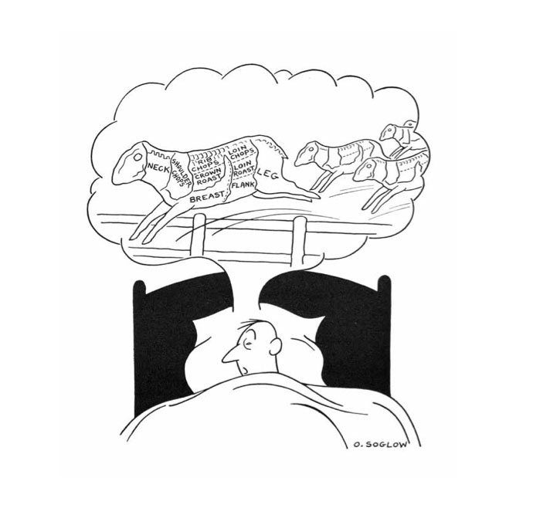

Copyright 2017 Larry Moen, M.Ed LPC Uncommon Therapy www.utherapy.net

